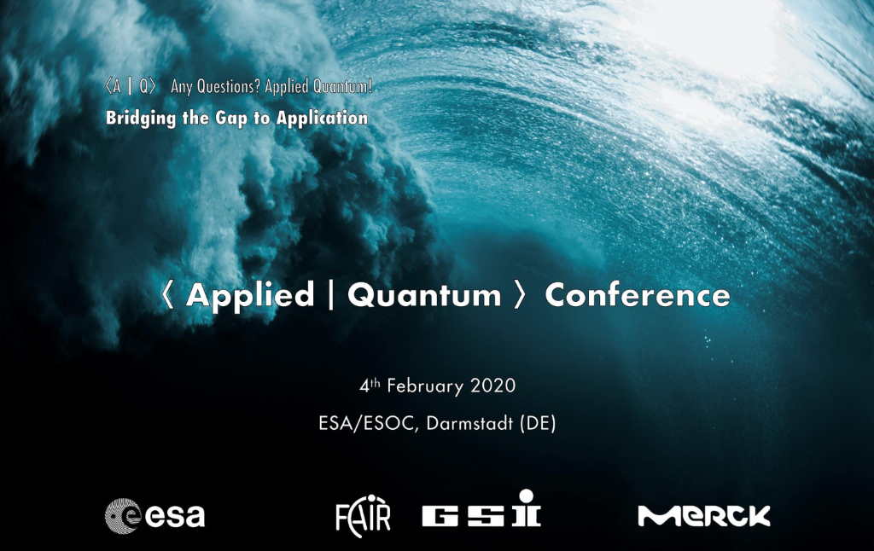

## APPLICATION FORM

|  |  |  |  |
| --- | --- | --- | --- |
| Personal Information | | | |
|  | | | |
| **Name:** |  | | |
| **Address:** |  |  |  |
|  |  | **Post Code:** |  |
| **Contact No. :** |  | | |
| **Email:** |  | | |
|  | | | |
| Employment details | | | |
|  | | | |
| |  |  |  | | --- | --- | --- | | **Institution:** |  | | | **Job Title:** |  | | |  | |  | | **Who is funding your research?** | |  | | **Are you in the first four years of your research activity?** | |  | | **Have you completed or are you in process of completion of your PhD?** | |  | | | | |
| Research | | | |
|  | | | |
| Abstract of your research (250 words)    **Would you like to present a Poster? Y/N**  What field is your research in (100 words)    Keywords for your research (6 keywords)    Purpose of your research (200 words)    What is the stage of development of your research? i.e. technology readiness  Please tick which is relevant   |  |  | | --- | --- | | Basic principles observed and reported |  | | Applications identified |  | | Proof of concept demonstrated |  | | Technology developed |  | | Technology validated in a simulated environment |  | | Technology tested in environment |  |   Where do you think your research could be applied? (200 words) | | | |

**Provide your personal grounds for participation in the Applied Quantum Conference? (max. 250 words)**