**Kurzbericht cw-Linac (W. Barth, 16.07.19):**

- set up of new test bunker ongoing: Production of two shielding bricks at HochTief ordered

- tender for solenoids finished

- bidder competition for rf-amplifiers still ongoing

- Start procurement procedure of ultrapure niobium for two sc-rebuncher cavities

- Leak testing at CH2 (University of Frankfurt)

- Delivery of MESA-cryomodule delayed by more than 2 months => Revised planning/preparation of first demonstrator cold test at HI-Mainz fixed

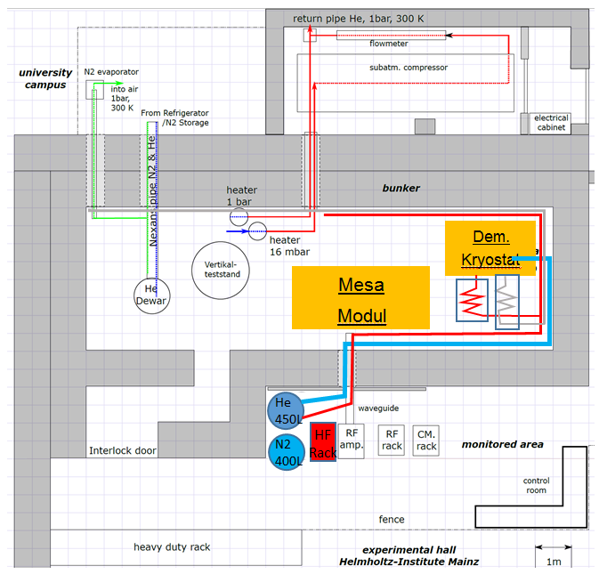

- Z-Buncher still under revision

- Budget planning for cw-Linac prepared

- Preparation for LHe-Transferline installations ongoing