**Kurzbericht cw-Linac (W. Barth, 25.06.19):**

- set up of new test bunker ongoing

- Upgrade of access to the test area ongoing

- 2nd call for of solenoid ongoing

- procurement procedure for rf-amplifiers ongoing

- Start procurement procedure of ultrapure niobium for two sc-rebuncher cavities

- planning/preparation of first demonstrator cold test at HI-Mainz

- Z-Buncher under revision

- construction meeting (LHe-transfer line, advanced demonstrator test area) this week

- Further planning of Advanced Demonstrator activities at GSI and HI-Mainz:

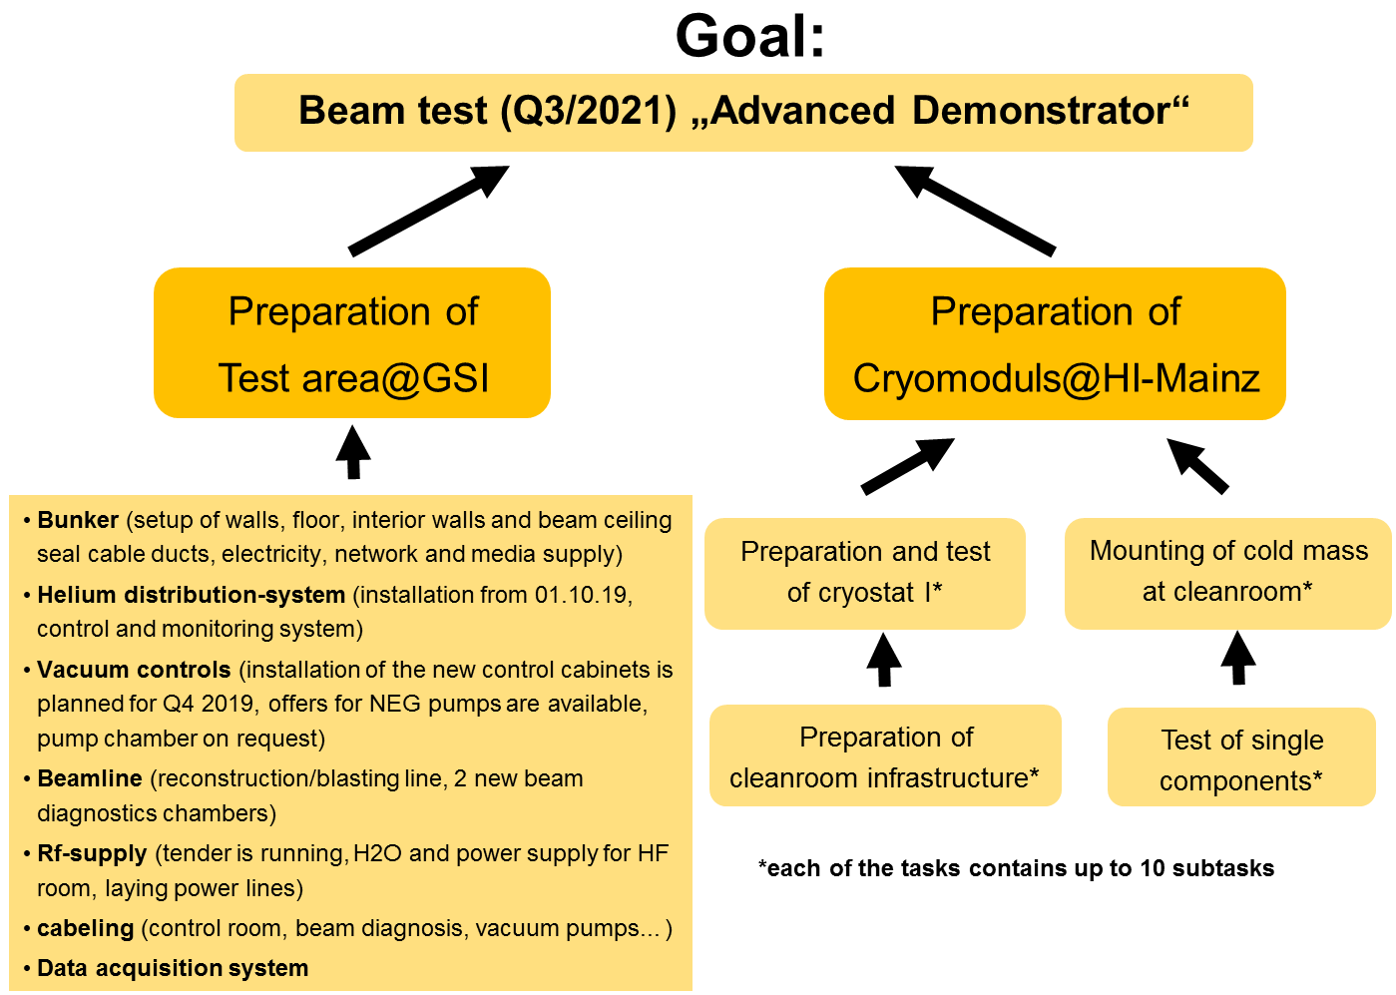

- Preparation for SRF-Workshop (1 invited talk, 5 poster contributions)