Kurzbericht cw-Linac (W. Barth, 18.06.19):

- set up of new test bunker
- Upgrade of access to the test area started

01/2019
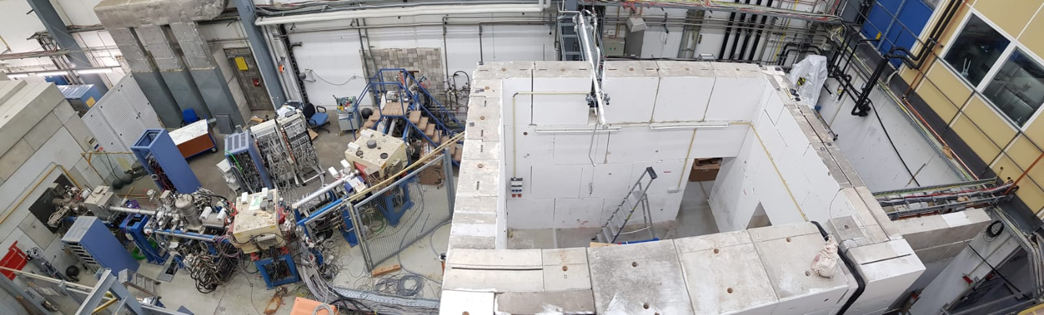

06/17/2019
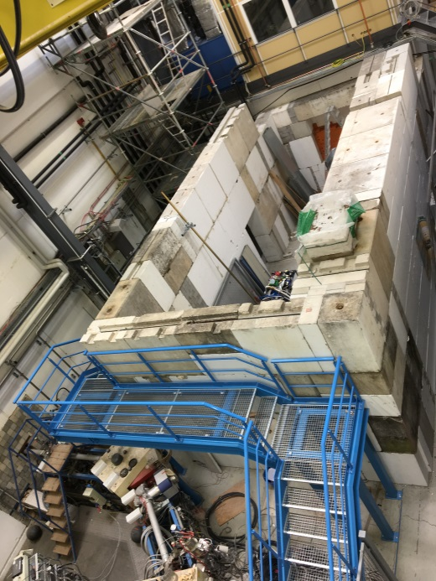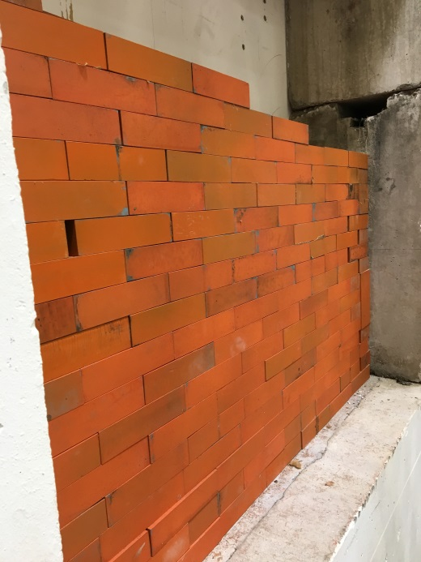

- Next steps:
-Installation of Water, RF and power supply
- Preparation of bunker walls, etc.
- Set up of beam line
- Set up of control room, rf-room, rf-Lab, etc. when all access doors are lock-able
- 2nd call for of solenoid started
- procurement procedure for rf-amplifiers ongoing
- Start procurement procedure of ultrapure niobium for two sc-rebuncher cavities
- leak search at CH2
- planning/preparation of first demonstrator cold test at HI-Mainz
- Z-Buncher under revision
- Design review CH3-5 (IAP)
Preparation for SRF-Workshop

