Kurzbericht cw-Linac (W. Barth, 04.06.19):

- set up of new test bunker
- Upgrade of access to the test area started

01/2019
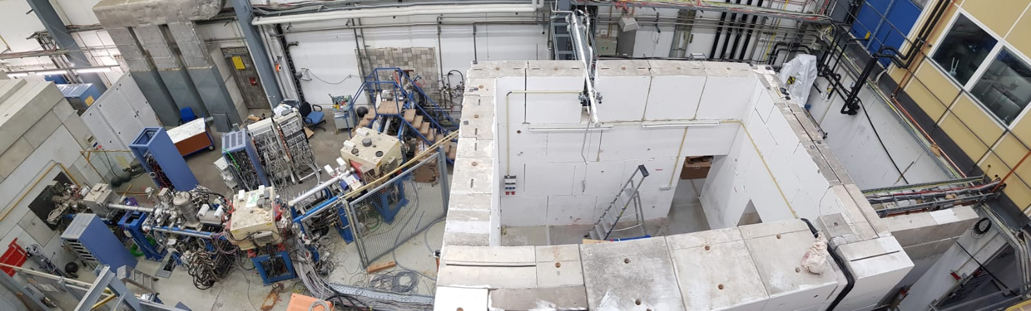

05/17/2019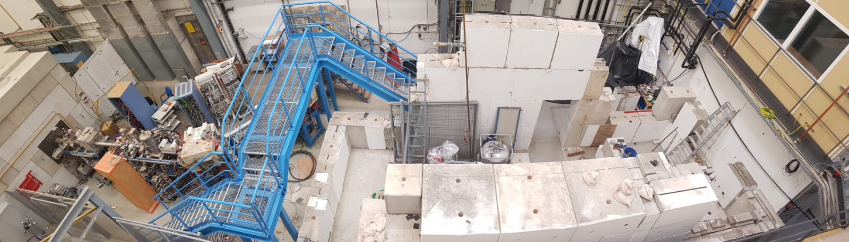

06/04/2019
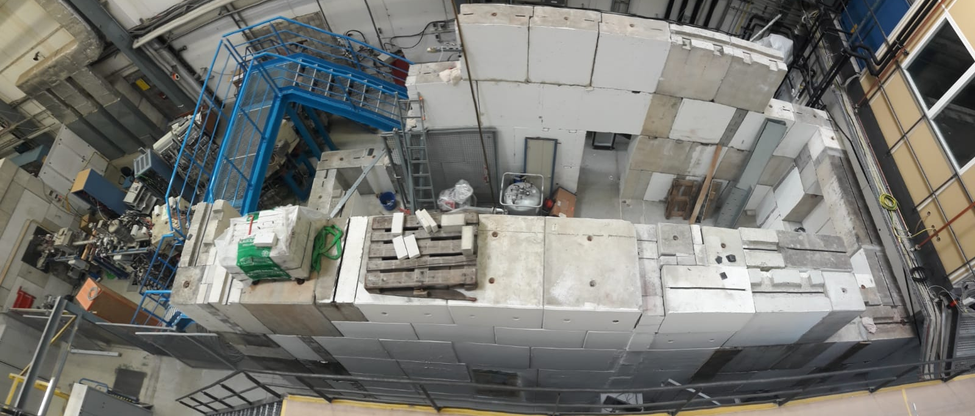

- Planning as last week:
-Installation of Water, RF and power supply after installation of the bunker
- Preparation of bunker walls, etc.
- Set up of beam line
- Set up of control room, rf-room, rf-Lab, etc. when all access doors are lock-able
- procurement of solenoids: No offers!
- procurement procedure for rf-amplifiers
- Start procurement procedure of ultrapure niobium for two sc-rebuncher cavities
- New antenna for CH1 delivered to RI
- Cold leak at CH2 – searching the leak is ongoing
- RF high power coupler test to be scheduled
- Z-Buncher low level testing to be scheduled
- User meeting for new test area at SH1

- request from G. Alberin-Wolters (Sommerfest FSB => Guided accelerator tour:
- Ionenquellen ca. 5 Min.
- Unilac ca. 10 Min
- HKR ca. 5 Min
- ESR ca 15 min
- CAVE M ca 10 min
- tot. ca. 45 Min. (in 4 Gruppen)

