# A Paper for the GSI Scientific Report*

J. Lastname1,2, K. Musterfrau1, and C. Mustermann2,#

1GSI, Darmstadt, Germany; 2ANL, Argonne, IL 60439, U.S.A.

**Hint: This paper is usable as a prototype for your report. Just replace this content with your own.**

## Submission of Papers

Templates are provided for Microsoft Word and LaTeX. Authors must use the templates provided. The JACoW Styles and Macros menu, available in the Microsoft Word JACoW-GSI-2006.dot template, is designed to help authors format their papers correctly. Changing of the templates, of the layout and the macros is not allowed. You may need to change your macro security settings (Tools, Macros, Security) to use macros.

In general only one page per contribution is allowed, exceptions for large collaborations are possible (please contact: [scirep@gsi.de](mailto:scirep@gsi.de)).

Each author should submit the PostScript file and all of the source files (text and figures for LaTeX and complete document for MS Word). If you don't have the Adobe Universal PostScript Windows Driver installed on your PC please use the CERN document server http://cdsconvwin.cern.ch/ to convert your Word file to PostScript.

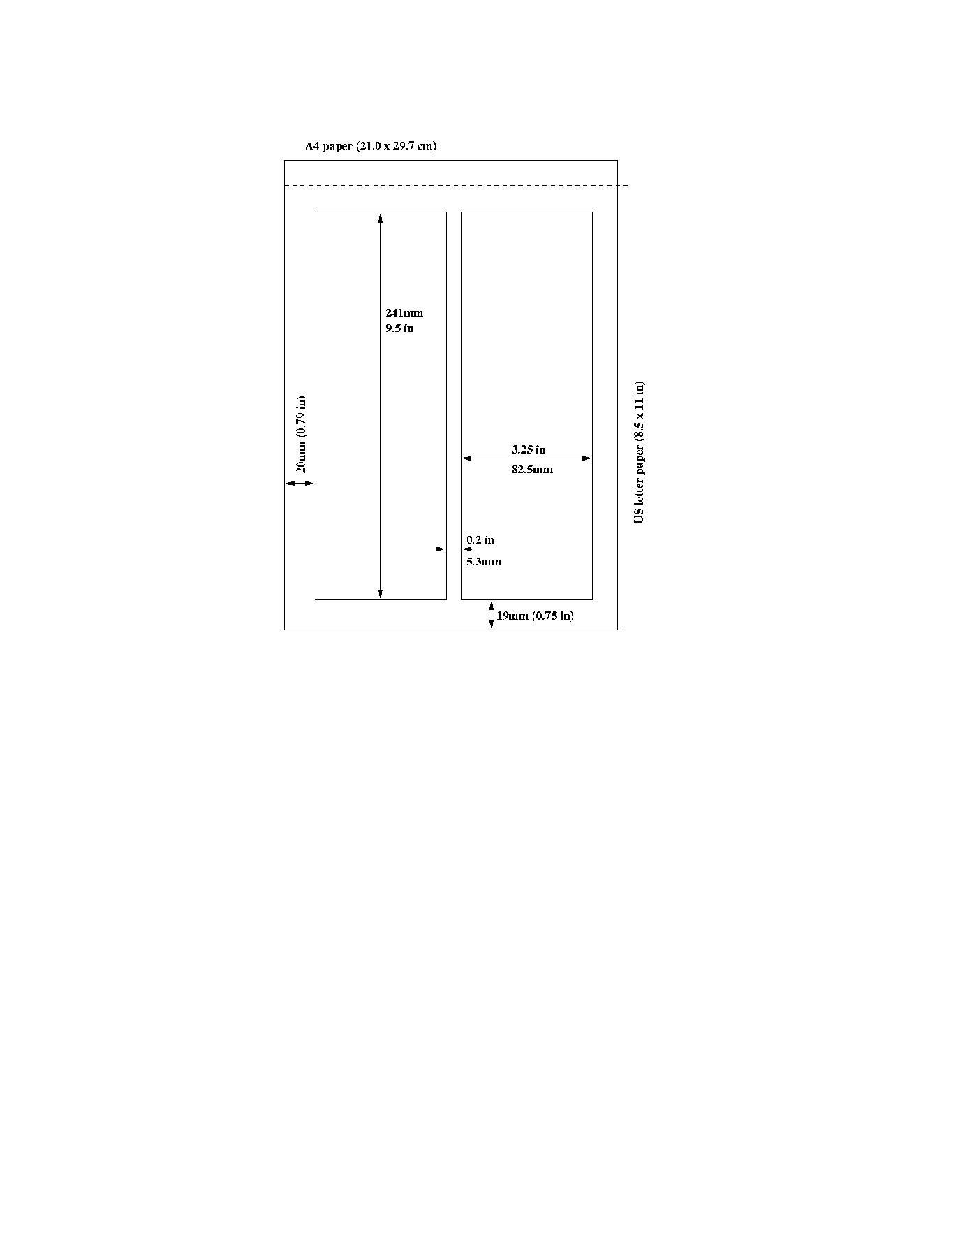Figure 1: example picture.

**Please use only the fonts of this template and Symbol font from the standard PostScript set of fonts.**

### Author List

The name of the submitting or primary author should be first, followed by the co-authors, alphabetically by affiliation.   
Word: Please use the defined format templates 'Author' and 'Institute' for the list.

LaTeX: Please use the defined macros 'authors' and 'affil' for the list.

### Section Headings

Section headings should not be numbered. They should use 12pt bold uppercase letters and be centred in the column. All section headings should appear directly above the text—there should never be a column break between a heading and the following paragraph.

### Subsection Headings

Subsection headings should not be numbered. They should use 12pt italic letters and be left aligned in the column. Subsection headings should appear directly above the text—there should never be a column break between a subheading and the following paragraph.

### Paragraph Text

Paragraphs should use 10pt font and be justified (touch each side) in the column. The beginning of each paragraph should be indented approximately 3 mm (0.13 in). The last line of a paragraph should not be printed by itself at the beginning of a column nor should the first line of a paragraph be printed by itself at the end of a column.

### Equations

If a displayed equation needs a number, place it flush with the right margin of the column (see Eq. 1). Units should be written using the roman font, not the italic font.

(1)



### Figures

The Scientific Report will be printed in black and white, so the figure and the related text should be understandable without colour (e. g. instead of "the red curve" use the term "the dashed curve", if you have a red dashed curve). Use of non-approved fonts in figures can lead to problems when the files are processed. Please use the approved fonts when possible.

All figures and tables must be given sequential numbers (1, 2, 3, etc.) and have captions (10pt font) placed below figures and above tables being described. Captions that are one line should be centred in the column, while captions that span more than one line should be justified.

* Work supported by EU, EURONS contract No. 506065.

#cee@aps.anl.gov

Text should not be obscured by figures. For more information on working with figures in Microsoft Word (including how to insert them in the most efficient manner), see the Microsoft Word help files.

The resolution of your figures should be about 400 DPI AND also printable in an acceptable time for the Internet version.

Figure 2: Example of a full-width figure showing the distribution of problems commonly encountered during paper processing.

### References

All bibliographical and web references should be numbered and listed at the end of the paper in a section called “References.” When referring to a reference in the text, place the corresponding reference number in square brackets [3].

### Footnotes

Footnotes on the title and author lines may be used for acknowledgements, affiliations and e-mail addresses. A nonnumeric sequence of characters (*, #, †, ‡) should be used. All other footnotes should be included in the reference section and use the normal numeric sequencing.

Word users—do not use Word’s footnote feature (**Insert**, **Footnote**) to insert footnotes, as this will create formatting problems. Instead, insert footnotes manually in a text box.

## Page Numbers

**DO NOT include any page numbers**. The editorial staff will add them when they produce the final proceedings.

## Checklist for electronic Publication

* Use only the fonts of this template and Symbol fonts for text - 10pt minimum.
* Text in figures should also be in fonts of this template and Symbol fonts when possible - 6pt minimum.
* Check that the PostScript file prints correctly.
* Check that there are no page numbers.
* Check the size of the PostScript file - an average size should be about 800-2000 KByte. If the file size is over 8 MByte, your have to make it smaller.

## References

[1] C. Petit-Jean-Genaz and J. Poole, “JACoW, A Service to the Accelerator Community”, EPAC’04, Lucerne, July 2004, p. 249, http://www.jacow.org.

[2] A. Name and D. Person, Modern Editor’s Journal 25 (1997) 56.

[3] A.N. Other, “A Very Interesting Paper”, EPAC’96, Sitges, June 1996, p. 7984.