# An Abstract for the Workshop

J. Lastname1,2, K. Musterfrau1, and C. Mustermann2

1GSI, Darmstadt, Germany; ITEP, Moscow, Russia

## Submission of Abstracts

### Templates are provided for Microsoft Word and LaTeX, authors must use these and should not change the templates, for example using different fonts and fontsizes. Abstracts should not exceed 1 page. Each author should submit also a PDF-file of the abstract but at least all of the source files.

### Author List

### The name of the submitting author - if also the presenter of the talk or poster at the workshop - should appear first, followed by the co-authors in alphabetical order. In a separate line the affiliations of the authors should be given.

### Section Headings and Paragraph Text

Section headlines should not be numbered. They should use 11 pt bold letters and be centred. Subsection headlines should be 11 pt italic and justified to the left side. Text in the parapgraphs should use 11 pt font and be justified (to each side). Indents at the beginning should be ~ 3 mm.

*Equations*

If a displayed equation needs a number, place it to the right margin of the text (see Eq. 1)

(1)



### Figures

All figures and tables must be numbered and have captions (11 pt font) placed below figures and above tables. One line captions should be centred, otherwise justified to the left side.

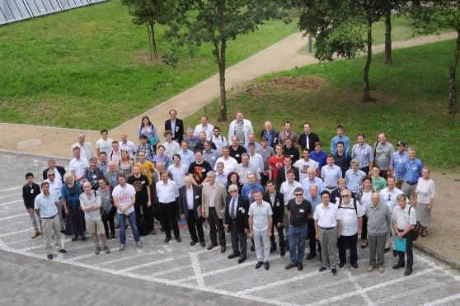

Figure 1: example picture

*Page Numbers*

DO NOT include any page numbers

References

[1] C. Petit-Jean-Genaz and J. Poole, “JACoW, A Service to the Accelerator Community”, EPAC’04, Lucerne, July 2004, p. 249, http://www.jacow.org.

[2] A. Name and D. Person, Modern Editor’s Journal 25 (1997) 56