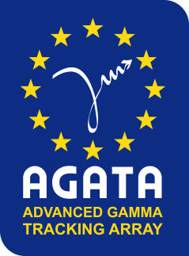
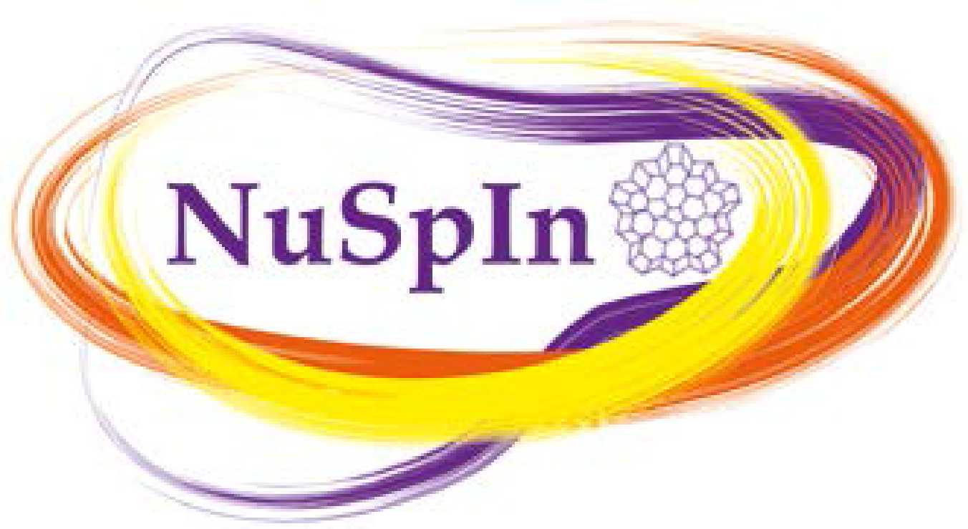

Second Workshop of the
Nuclear Spectroscopy Instrumentation Network
NUSPIN 2017

Associated Events:
Annual Open Meeting of the AGATA Collaboration
Meetings of the NUSPIN Working Groups and Scientific Committee

GSI Darmstadt, June 26th – 29th, 2017

FIRST CIRCULAR

We have the pleasure to announce that the Second Workshop of the Nuclear Spectroscopy Instrumentation Network of ENSAR2, NUSPIN 2017, will take place at GSI Darmstadt on June 26th – June 29th, 2017 and will host the AGATA Collaboration Meeting.

SCOPE AND TOPICS

The Nuclear Spectroscopy Instrumentation Network (NuSpIn), in the framework of ENSAR2 (HORIZON2020), promotes the mutual coordination between the research groups involved in high-resolution gamma-ray spectroscopy. The objective is to strengthen the nuclear structure community by the exchange and transfer of knowledge and the enhancement of synergies between the different collaborations active in the European Infrastructure Facilities.

The aim of the NUSPIN 2017 Workshop is to present the status of the instrumentation for nuclear structure research at the European facilities and to discuss the perspectives. Sessions will be dedicated to the presentation of recent nuclear structure experimental as well as theoretical studies, the latest results obtained at the gamma-ray facilities in Europe, the preparation status of the RIB facilities, and the discussion of the challenges of future research, the development of new instrumentation and technical developments with gamma-ray techniques and particle detectors.

The main topics to be discussed at the workshop are:

• spectroscopy with radioactive ion beams
• shell structure far from stability
• isospin degrees of freedom
• collective excitations
• nuclear moments
• nuclear astrophysics
• gamma-ray detectors technology
• complementary instrumentation

The workshop will start on the afternoon of Monday 26th June and will finish by 5:30pm on Thursday, June 29th.

Meetings of the NUSPIN Scientific Committee and Working Groups

The afternoon of Wednesday 28th June will be devoted to the meetings of the NUSPIN Scientific Committee and of the Working Groups coordinating the instrumentation developments.

Annual Meeting of the AGATA Collaboration and
AGATA Collaboration Council Meeting

Thursday 29th June will be dedicated to the Annual Meeting of the AGATA Collaboration which includes presentation on the status of the campaigns, the perspectives, and the status of the analysis of the different experiments. The meeting will be followed by the meeting of the AGATA Collaboration Council meeting (closed session).

WORKSHOP VENUE

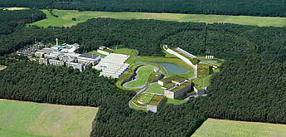
The GSI/FAIR facility

The Workshop will take place at GSI Darmstadt:
https://www.gsi.de/en/start/news.htm

GSI Helmholzzentrum für Schwerionenforschung GmbH is a Research Institute which operates a worldwide unique large-scale accelerator facility for heavy ions and currently employs about 1100 people. In addition approximately 1000 researchers from universities and other research institutes around the world use the facility for their experiments.
GSI is a limited liability company (Ger. GmbH). Associates are the German Federal Government (90 per cent), the State of Hessen (8 per cent), the State of Rhineland-Palatinate (1 per cent) and the Free State of Thuringia (1 per cent). They are represented in the board of directors by the Federal Ministry of Education and Research and the respective Ministries. GSI is a member of the Helmholtz Association, Germany's largest research organisation.
Currently the international accelerator center called FAIR (Facility for Antiproton and Ion Research) – one of the largest research projects in the world – is being built adjacent to GSI.
https://www.gsi.de/en/researchaccelerators/fair.htm

REGISTRATION

Participants are invited to register using the registration form available in the website from 17th February to 16th June 2017.
Financial support may be available on request for young researchers wishing to attend the Workshop.

ABSTRACT SUBMISSION

Review talks will be followed by shorter contributions selected from the submitted abstracts.
The deadline for abstract submission is 15th April 2017. Information regarding the abstract selection will be notified to the contributors by 15th May 2017.

SOCIAL EVENTS

On Monday evening all the participants of the workshop are invited to the reception which will take place at GSI.

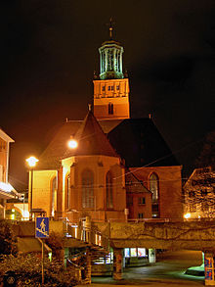
The city Church of Darmstadt

On Tuesday 27th June late afternoon will be devoted to social events
including the organ concert “Orgelmatinée” in the city Church of Darmstadt
http://www.darmstaedterkantorei.de/ and the workshop dinner at the Sitte restaurant www.restaurant-sitte.de located in the walking distance from the Church. More details on the social events will be specified in the next circular.

IMPORTANT DATES

- Registration: from 17th February to 16th June 2017
- Deadline for abstract submission: 15th April 2017
- Contributors notification: 15th May 2017

ACCOMMODATION

A list of hotels in Darmstadt can be found on the web site of the workshop:
http://indico.gsi.de/event/nuspin2017

CORRESPONDENCE

Please address all correspondence by electronic mail to:
s.saha@gsi.de or m.gorska@gsi.de

WEB PAGE
Updated information on the Workshop can be found on the web page: http://indico.gsi.de/event/nuspin2017

ORGANIZATION

Organizing Committee

Magdalena Górska (GSI, Darmstadt)(chair)
Silvia Lenzi (University and INFN, Padova)
Andrew Boston (University of Liverpool)
Andres Gadea (IFIC-CSIC, Valencia)
Araceli López-Martens (CSNSM, Orsay)
Sudipta Saha (GSI/TU Darmstadt)
P-A. Söderström (GSI/TU Darmstadt)
Guangshun Li (GSI/IMP Lanzhou)
Tugba Arici (GSI/University of Gieβen)
Johan Nyberg (Uppsala University)

Secretariat

l.doersching-steitz @ gsi.de

