SOFTWARE TOOLS FOR THE ATLAS SUPERCONDUCTING ACCELERATOR*†
Maria A. Power, Matthew Hendricks, Christopher Peters, Caleb Whitaker,
ANL, Argonne, IL 60439, USA
Abstract
At ATLAS (the Argonne Tandem Linac Accelerator System) several software tools are utilized by the operations group in order to assist in the operation of the accelerator. One such tool is the Operators Notebook, which includes a shift log, experiment up and downtime tracking, and equipment tracking. A second tool, called Paradox, archives the equipment control settings from running experiments and allows them to be optionally scaled and loaded back into the accelerator control system for other experiments. In this paper, I will discuss these and other tools used at the facility to assist in the accelerator operations.

ATLAS
The ATLAS Control System Group is responsible for all the computing and controls for ATLAS Operations beginning with the ION sources and up to (but not including) the target areas. There are many systems and tools managed including: the control system, Paradox archival system, the Hercules legacy operators tools suite, the Document Index, the Operators Notebook tools suite, a SharePoint BBS, Radiation Safety Systems, and various Website(s).
The ATLAS Control System primary systems use an AlphaServer running OpenVMS and CAMAC hardware. Additionally, we are transitioning to distributed Linux based controllers using VME Crates and Hytec 9010 Blade Controllers using Industry packs for I/O.
The control system software used is the commercially available Vista Control Systems, Inc. – VSystem which is available for OpenVMS, Linux, (and Windows). VSystem provides many tools to provide functionality including logging, graphing, and alarming tools.

Paradox ARchival System

ATLAS Data Management
Snapshots of the accelerators parameters and control values are constantly updated into Oracle RDB tables for use by other systems. The Paradox archival system reads these tables at least every 4 hours and stores them into its database (Figure 1) with a time and date stamp. Operators can also force a reading at any time and add a comment to particular readings.
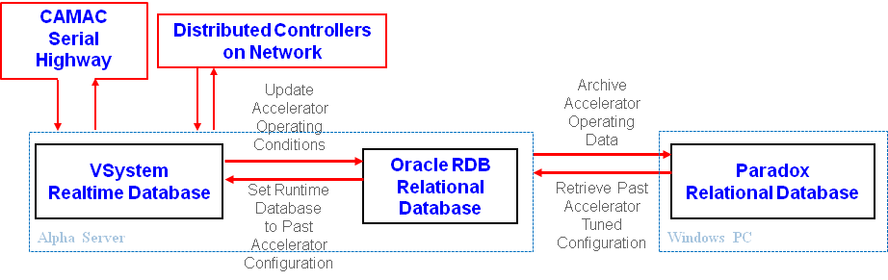
Figure 1: ATLAS Archival Data Flow.

Paradox
The Paradox software allows the operators to view the stored data (Figure 2) and select a particular snapshot to optionally scale and load back into the system. (Figure 3) The loaded tune can be applied to the entire beamline or a particular subsection.
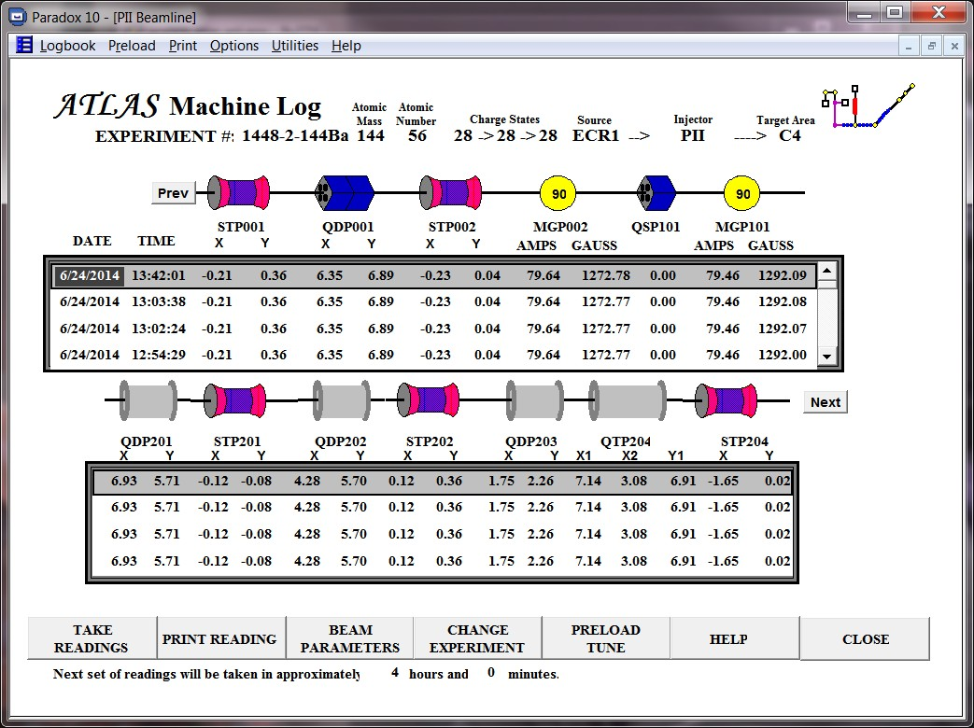
Figure 2: Paradox Data View.
Figure 3: Paradox Load Tune.
* This material is based upon work supported by the U.S. Department of Energy, Office of Science, Office of Nuclear Physics, under contract number DE-AC02-06CH11357
† This research used resources of ANL’s ATLAS facility, which is a DOE Office of Science User Facility
Applying the tune only places the data into a table on the control system primary server. An operator must then initiate the actual load into the accelerator devices from a control system screen. The ability to load and scale previous tunes greatly improves the start-up times for experiments.

operation tools

Hercules
Hercules is a MS-DOS Based software application created using a database package called Alpha 4. The tools originally included in Hercules include a document catalog for drawings, Shift Log, Pin Diode Fuse Log, and Equipment Database and Maintenance Log.
Conversion to modern software of this package has been implemented in pieces using Java Swing applications and MySQL. Although there is a large development cost in time to this approach they were outweighed by the advantages of using readily available development software and tools, migrated the existing data easily, getting the exact functionality desired, and the ability to update the software quickly as machine configurations change.

Document Index
The first tool migrated from Hercules was the Document Index application. (Figure 4) Digital versions of most drawings were created and stored in the system. Full text searching and the ability to view the newly scanned documents were features added to the application. Initially, the Java application was available using Java Web Launch but due to security concerns and the need to install Java on each machine, a web page interface was implemented. (Figure 5)
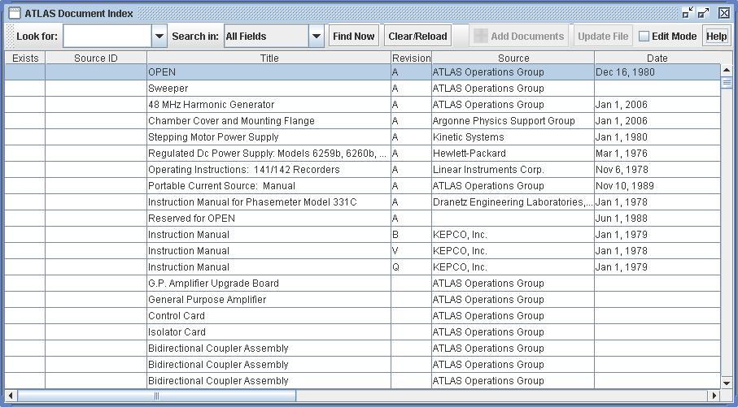
Figure 4: Document Index.
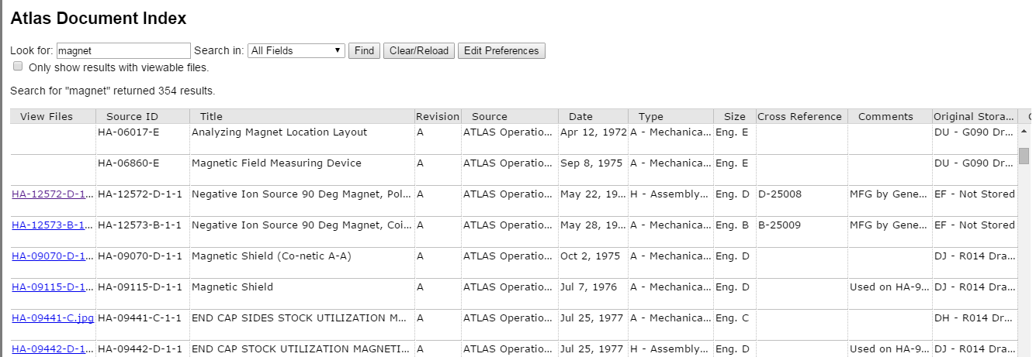
Figure 5: Document Index Web Interface.

Operators Notebook
The Operators Notebook comprises several of the tools ported from the old Hercules software: the Shift Log (Figure 6) and supporting functions and reports, and the Pin Diode Fuse Log. (Figure 7) Each shift log entry is tagged with a class (e.g. Research, Experiment Downtime, etc.), a category (eg. Ion Sources, Beamline, etc.) and an optional sub-system. The time allotment for each entry is automatically calculated. This categorization allows for tracking statistics and search options.
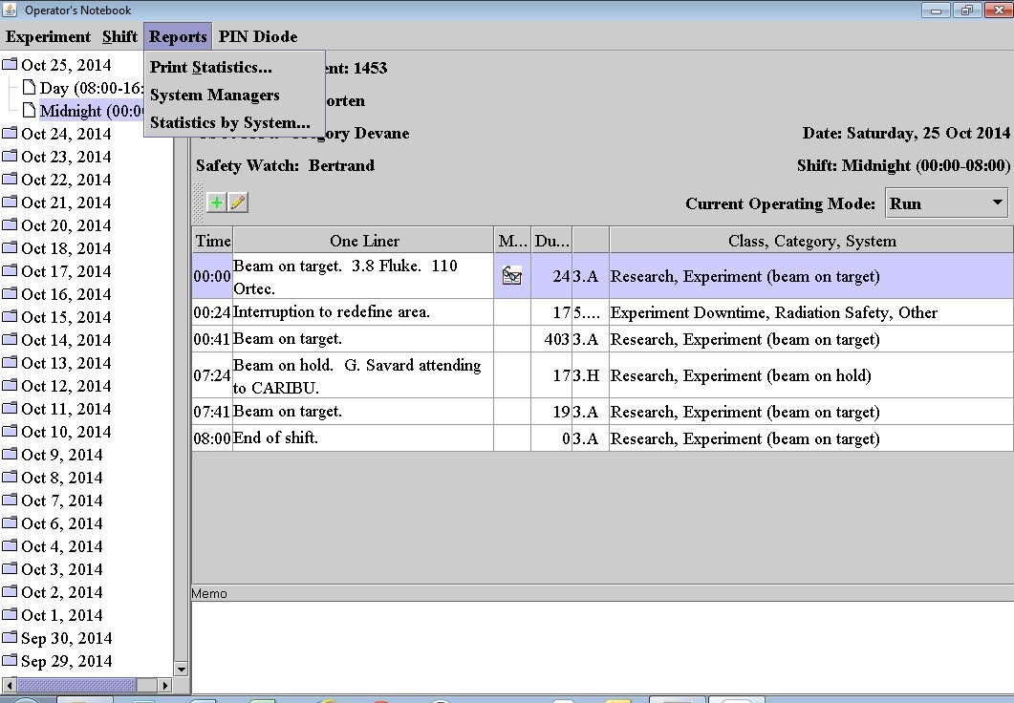
Figure 6: Operators Notebook – Shift Log and
Report Options.
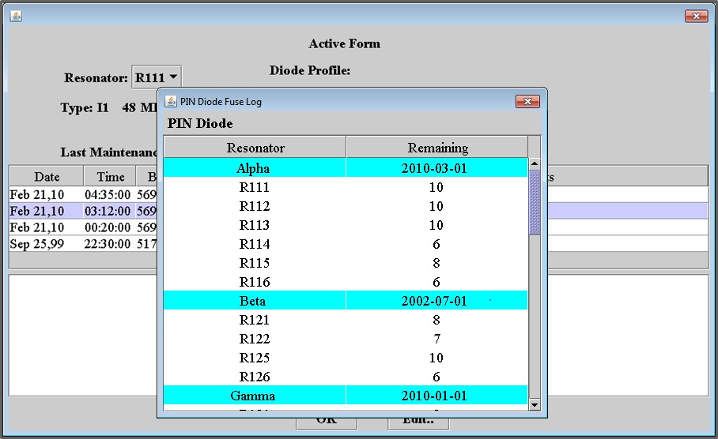
Figure 7: Operators Notebook – Pin Diode Fuse Log.
The Pin Diode Fuse Log is the most recent addition to the software package. Because the software framework already existed, the work was done in a short time (2 months) by a single student.
The last piece to be migrated is the Maintenance and Equipment data. While there are many existing software packages in existence that does this already, given the existing data and the existing software framework, it has been decided to continue on the path of using the Java application development.

Remote Operations
Remote control of the accelerator is obtained via a VPN connection into the control system network. Access is given to a limited group of personnel via their lab account login. Once ‘inside’ they can access the control system directly through an X-windows session and access the same control options that are locally available.
Remote viewing of current system status is also available through standard VPN and web pages tailored to specific subsystems. (Figure 8) To achieve this, the data is collected via the Oracle RDB and the pages are pushed to an external web server. (Figure 9) Examples of the information available include ion source status, vacuum systems, cryogenics systems, and latest shift log entries.
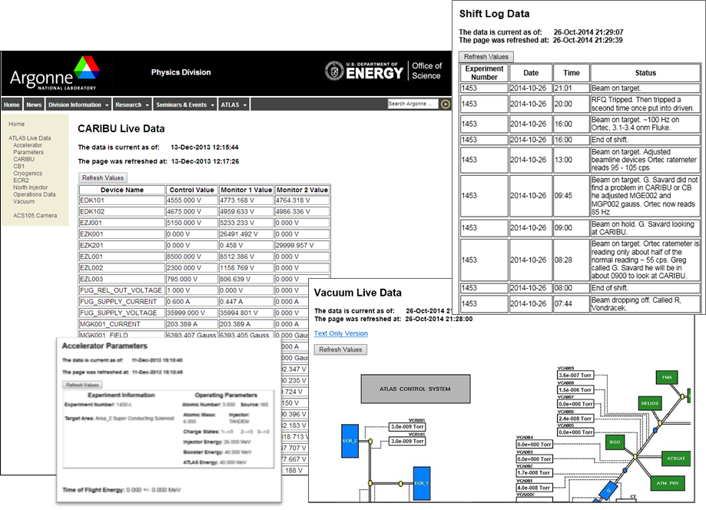
Figure 8: Live Data Web Pages.
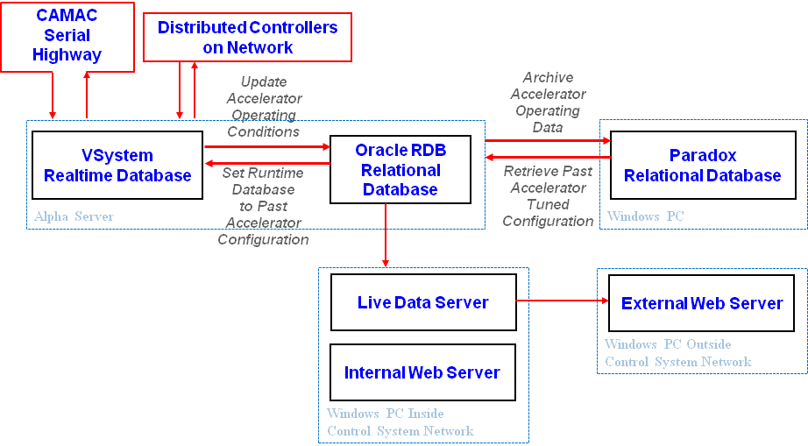
Figure 9: ATLAS Accelerator Parameters Data Flow.

summary
Only the primary operations tools have been discussed. Many more tools are available to improve operational efficiency. Integration of external equipment and controls (e.g. LabView), alarming, reports, and procedure automation tools are just a few examples.
The ATLAS Controls Group is always on the lookout and open to ideas to improve operations and to meet the needs of the operations staff and accelerator users.

