Strategy of the
Research Field Matter
for PoF V
Strategy Paper

This paper outlines the status of the strategy for PoF V and it will be part of the discussion during the scientific evaluation 2025. It will be included in the status report: the first two sections at the beginning, the remaining sections as the outlook of the Research Field.
Please follow the corporate design of the Helmholtz Association and use standardized language (see glossary).
The document should not exceed 10 pages
Please use: American English Language, Font Arial 10, Line spacing 13 Pt.; Paragraph spacing 6 Pt. The page margins must be 2.5 cm at the top, left and right, and at least 2.0 cm at the bottom.
If possible, please refrain from using the usual Helmholtz terms and abbreviations in this document. Please write in more general terms for a (scientific specialist) audience that is not necessarily familiar with Helmholtz.

Content
1 Research field Matter and its current research portfolio 1
2 National and international context 2
3 Challenges for the next ten years 3
4 Mission and research objectives 3
5 Future thematic and programmatic positioning 4
5.1 Scientific positioning 5
5.2 Structure of the Research Field 8
5.3 Role and Impact of infrastructures 9
5.4 Internal and external cooperation 10
5.5 Matter Competence Teams 10
5.6 Commitment to strengthening and advancing our workforce and infrastructures 11
5.6.1 Advancing infrastructures: Photon Science Roadmap 11
5.6.2 Talent management and Equal Opportunities and Diversity 11
5.6.3 Innovation 12
5.6.4 Knowledge transfer 12
5.6.5 Sustainability 12
5.6.6 Digitalization 13
6 Annex 14

Excerpt from the Verfahrenspapier:
Die als Ergebnisse des Strategieprozesses vorzulegenden Strategiepapiere sollen der folgenden für alle Forschungsbereiche gemeinsamen Gliederung folgen: Aktuelles Forschungsportfolio
- Einordnung in den nationalen und internationalen Kontext
- Herausforderungen der nächsten 10 Jahre
- Mission und Forschungsziele des Forschungsbereichs
- Zukünftige thematische und programmatische Aufstellung
  - Wissenschaftlich-programmatische Ausrichtung
  - Struktur des Forschungsbereichs
  - Rolle der Infrastrukturen im Forschungsbereich
  - Kooperationsstrategien (intern / extern)
  - Strategien zu programm- und FB-übergreifenden Themen wie z.B. Digitalisierung
  - Strategien zu zentrenbezogenen (forschungs-)politischen und/oder strukturellen Themen wie z.B. Innovation und Transfer / Talentmanagement, Nachhaltigkeit, Parität (Chancengerechtigkeit), Diversität, Digitalisierung
- Das abschließende Strategiepapier wird in die Status Reports für die wissenschaftlichen Begutachtungen und den Programmantrag des Forschungsbereichs für die strategische Bewertung integriert.

- Research field Matter and its current research portfolio
In the Research Field Matter, the Helmholtz Centers
DESY, FZJ, GSI (with HI Jena and HI Mainz), Hereon, HZB, HZDR and KIT
closely collaborate, operating and exploiting state-of-the-art large-scale research facilities, to explore the structure of matter from sub-atomic to molecular scales and to investigate relevant structural details and processes within new and novel materials and biologically relevant structures. The Research Field Matter generates in this way new insights into the understanding of the Universe and into the atomic and molecular foundations essential for the development of customized materials and new drugs.
The Research Field offers a quality-assured access to its cutting-edge large research infrastructures for a large national and international user community from the academic and industrial sectors, in particular to young investigators starting their scientific careers.
Another important characteristic of the Research Field is its strategic cooperation within and leading contributions to large international research projects. In this way the interdisciplinary research facilities and international networking in long-term large-scale projects constitute an important pillar of the German science system.

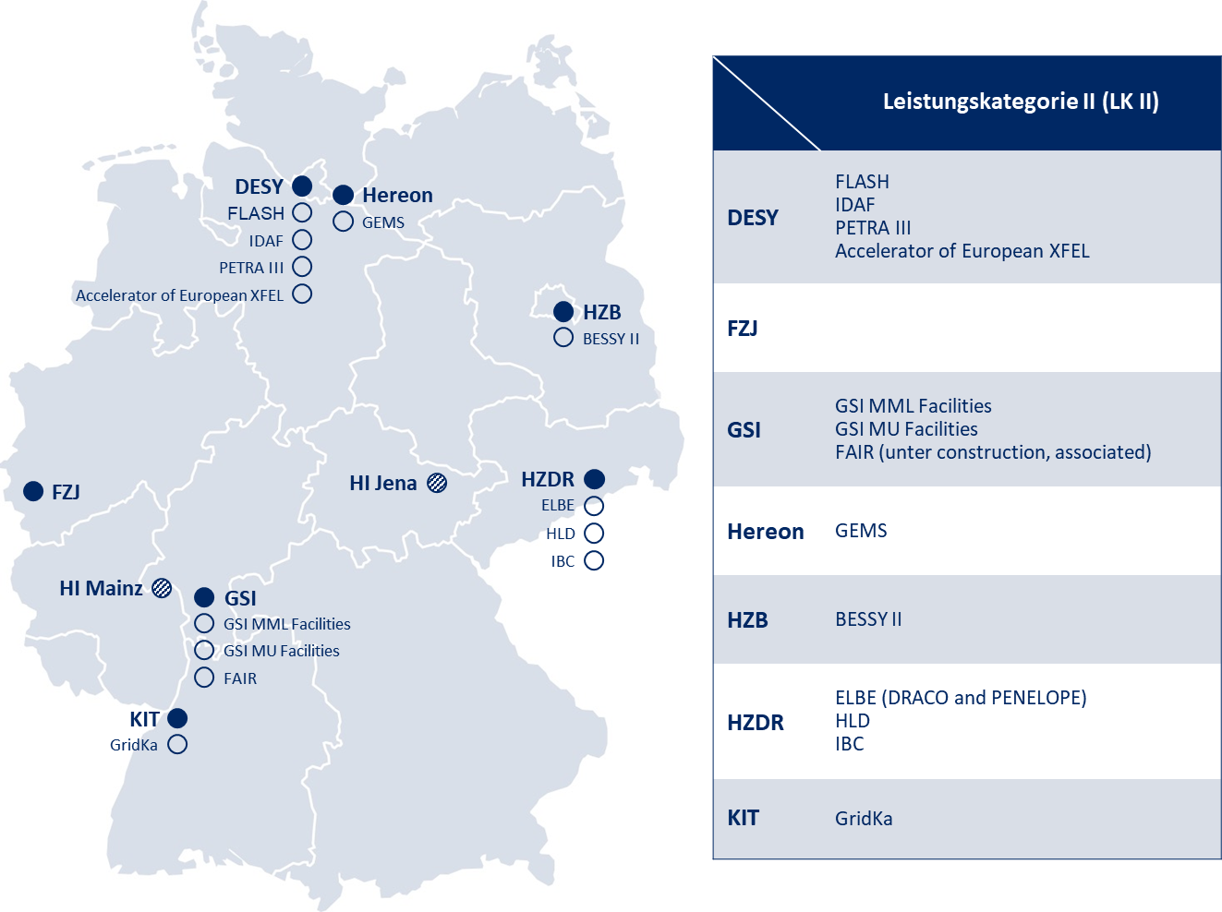
Figure 1: Helmholtz Centers ( ), Helmholtz Institutes ( ) and research infrastructures with prioritized funding scheme ( , so-called LK II – “Leistungskategorie II”) of the research field Matter in PoF V
The Research Field has developed a world-class research program in fundamental and applied science and technology which is largely based on the exploitation of its large-scale research infrastructures which it operates itself and in which it is participating in international collaborations. This research makes intensive use of the capabilities within Matter to efficiently extract knowledge from the vast amounts of complex data produced by the research infrastructures.
The Research Field has devised and implemented an efficient interdisciplinary cooperation structure with the aim to create added value in science, technology development and transfer as well as in talent management. The research portfolio is organized into three research programs:
- Matter and the Universe (MU),
- Matter and Technologies (MT), and
- From Matter to Materials and Life (MML).
This structure was first introduced in the funding period PoF III and has led to many synergies in the collaboration between the centers. Since its start in PoF III, the program MT has proven to be very successful, as research and development in essential key technologies are carried out in a strategic cooperation between the centers that are highly relevant for keeping the large-scale research facilities at the forefront of science. The technologies include advanced accelerators and detectors, as well as high performance data and computing systems

- National and international context
The portfolio of the Research Field Matter and its close interdisciplinary collaboration across multiple centers are internationally pioneering. With its modern program structure, the Research Field Matter is an internationally leading concept enabling close cooperation across a wide range of research disciplines, very often funneled by the nature of its research infrastructures.
National context
At the national level the Research Field Matter fulfills mainly two strategic tasks: Firstly, it is responsible for the design, construction and operation of state-of-the-art research infrastructures, notably accelerator-based photon sources (Synchrotron- and X-ray Laser-radiation facilities), neutron and ion facilities as well as of high-field and neutrino laboratories, including dedicated large-scale computing facilities. Secondly, it is a key strategic partner in international large-scale research collaborations.
Thirdly, these Matter-operated facilities enable world-class research and technological development in the research field along with quality-assured open access to research groups from all around the world. This well-established user operation fulfills a national strategic role and provides a signature model of work sharing between university-based and national lab-based research: experts of the Research Field Matter offer their competences and assistance to scientists from all sectors of academic research, and especially early-career researchers, to fully exploit the scientific potential available at the research infrastructures. Increasingly, the centers within Matter are also developing more efficient concepts to facilitate access and use of these technologies for industrial research groups.
International context
The Research Field is very strongly interconnected with leading international large-scale projects, shaping the landscape in Europe, but also as strategic partner in north and south America, Asia, in particular in Japan, and all around the world, especially in the fields of particle, hadron, and astroparticle physics. These cooperations need to be maintained and further strengthened, e.g. increasing the participation of Matter researchers in EU projects. Regarding the necessary modernization and upgrades of its research facilities, the Research Field Matter is moving in a highly competitive international landscape striving for the best technologies and ultimately for the leading research groups, which are attracted by the best research opportunities. Currently, this particularly concerns photon sources and facilities of exotic secondary beams, which are being upgraded worldwide with new transformative technologies.

- Challenges for the next ten years
Due to the very fundamental nature of its research program, the Research Field Matter has a rather long-time horizon for its research objectives. On the other hand, the Research Field is increasingly focusing on solutions to the pressing societal challenges of today and tomorrow in its strategic considerations. Matter will make essential contributions to many of the European Commission's strategic development goals and will increasingly cooperate with industry in their deep-tech developments.
In a new challenging geopolitical world, the Research Field also sees itself responsible for contributing to the country's technology sovereignty and for strengthening the national science and innovation ecosystem through providing cutting-edge technologies. At the same time, the Research Field and its endeavors are based on long-term international collaborations, and thus contribute to a stable communication channel across borders also in difficult geopolitical times as we see today.
The Research Field Matter has cast its ambitions into a list of grand challenges, structured along the programs of the Research Field.
Matter and the Universe
- Understanding of the nature of dark matter, the origin of the matter-antimatter asymmetry in the universe, and the properties of neutrinos.
- Studying hadronic matter under extreme conditions in the laboratory, which is essential for unraveling the origin of heavy elements in the universe.
- Understanding the connection of particle physics with the processes in the universe and how the most extreme events shape our universe.
Matter and Technologies
- Meeting the demands for ever more powerful accelerators and detectors, generated within the research in Matter, including the strategic development of potentially disruptive technologies, the exploration of new and emergent ideas, and moving them from the realm of fundamental research into the application.
- Answering to the enormous increase in data recorded in Matter and, more generally, in research, and developing efficient ways to turn data into knowledge
- Developing new technologies which reduce the environmental footprint in particular of research infrastructures, and research in general.
From Matter to Materials and Life
- Understanding of matter under extreme conditions, of strong-field processes from the THz to the X-ray range, of the warm dense matter state that is central both to inertial confinement fusion and to astrophysical objects, and of processes on ultrafast time scales.
- Tailoring and optimization of materials for quantum technology, sustainable energy, and engineering processes.
- Science-driven drug development supported by structural biology and AI-facilitated generation of new compounds and macro-molecules as well to strive for improvements of radiotherapy in oncology.

- Mission and research objectives
Our mission is to explore the structure and properties of matter and the universe as well as the data-based molecular design of new material functions and biological systems, utilizing large-scale research facilities for investigations across all relevant length and time scales.
A key part of our mission is to make the unique analytical potentials of its infrastructures accessible to a wide range of users from the academic and industrial sectors.
Through its contribution to the national technological sovereignty and the provision of cutting-edge technologies for science and society, we significantly strengthen Germany's position as science and innovation hub (“Wissenschafts- und Innovationsstandort”).
We stand for an international and diverse research environment, attracting and fostering the education of young high-potentials in operating in a globally responsible manner.
Matter and the Universe
Our mission is to understand the Universe on all energy, length and time scales, and to connect the evolution of the cosmos and its phenomena to the fundamental physics of the microcosmos and the basic constituents of matter.
We strive to enable an optimal knowledge gain through the development, construction, operation, and efficient utilization of cutting-edge research and computing infrastructures in an international environment. These encompass world-leading high-energy accelerator experiments and large-scale astroparticle physics observatories. Furthermore, we develop theoretical foundations of our understanding of the Universe and devise innovative methods for simulations and data analysis, employing modern computing technologies like artificial intelligence and quantum computing.
Matter and Technologies
Our mission is to conceive enabling research technologies which are “driven by science and driving science”.
We leverage emergent and sustainable technologies in an integrative approach in accelerator, detector and data sciences to create new opportunities for sustainable cutting-edge research in Matter and beyond. We push technologies for accelerators and detectors and we develop schemes to efficiently and safely store data and make them accessible to science and to provide low-carbon footprint and resource responsible systems.
We strengthen research in technology as a field, train the next generation of engineers and scientists in our field and link into areas such as energy-, information-, and health-science, and society at large.
From Matter to Materials and Life
Our mission is to elucidate the molecular and electronic structures and processes within condensed matter, materials and biological structures with utmost precision and in relevant environments, thus laying the groundwork for the development of better materials for future eco-friendly technologies and a circular economy, as well as the data-based design of new pharmaceuticals.
To this end, we operate onsite state-of-the-art large-scale research infrastructures, which we make available to both the German and international science and technology community. We recognize our responsibility to contribute essential solutions to the major societal challenges of today and tomorrow.

- Future thematic and programmatic positioning
The future research program is being developed based on the scientific and technological knowledge and successes achieved during the current funding period. Specifically, the program structure, which has proven to be exceptionally effective, will be maintained (see section 5.2).
In terms of programmatic positioning, the Research Field recognizes a new responsibility to stronger contribute targeted solutions to current societal challenges, especially in combating climate change.

  - Scientific positioning
Matter and the Universe
Curiosity-driven research is at the core of the Program Matter and the Universe, determines our priorities, and drives what instruments we build and what experiments we design.
We strive to identify the most fundamental matter constituents, to study the forces that act between them at the highest possible precision, as well as to understand the influence of these fundamental building blocks and forces on the evolution of the universe.
- We push the limits of our understanding of fundamental interactions – strong, electroweak and gravitational – through precision measurements at large particle collider experiments and at novel medium-scale experiments at DESY.
- We investigate the origin of mass, the flavour puzzle, and the imbalance between matter and anti-matter through analyses at large particle collider experiments and theory developments related to Higgs bosons, top and bottom quarks, and tau leptons.
- We research the evolution of the early universe and the nature of the dark sector through theoretical developments and through experimental searches for new particles at large particle collider experiments, and at novel medium-scale experiments at DESY with a focus on searches for axions and high-frequency gravitational waves.
Focusing on studying hadronic processes in dense environments at GSI/FAIR and LHC, we strive to understand how the properties and dynamics of matter and antimatter arise from fundamental interactionsand how they determine the evolution of stars and shape nucleosynthesis.
- We determine the phase structure and the equation of state of QCD matter at extreme values of density, temperature and isospin as exist in neutron star merger events employing modern detector and computing technologies.
- We identify of the most important nuclear properties and mechanisms that determine the production of elements in the Universe and understand how nuclei emerge from the fundamental building blocks.
- We decipher the origin of matter-antimatter symmetry and test the fundamental symmetries.
Combining observations of the cosmos with our own experiments, we seek to understand the nature of dark matter, determine the properties of neutrinos and their role in the Universe, and study processes that govern the Universe at high energies.
- We build and operate detectors for the direct detection of dark matter in the laboratory. The flagship project will be DARWIN/XLZD, the successor to XENONnT.
- We develop and use novel technologies to unravel the mystery of neutrino mass and pave the ground for a new generation neutrino mass experiment as successor to KATRIN.
- We combine astrophysical observations and simulations in a multi-messenger approach to decipher the high-energy Universe. The flagship projects will be CTA, IceCube, and the Auger Observatory, with an extension of IceCube to IceCube-Gen2* being planned. We will work towards completing this portfolio with gravitational wave astronomy (Einstein Telescope*).
By operating large-scale accelerator and computing facilities for an international user community, we will enable groundbreaking insights into the understanding of the processes of the micro- and macro-cosmos.
- We provide hadron beams of the highest intensity and quality.
- We produce exotic secondary beams of high energy with excellent properties.
- We ensure optimal scientific return and data dissemination by providing large-scale and sustainably operated computing facilities (GridKa and Green IT Cube) and developing and implementing innovative simulation and analysis methods.

Matter and Technologies
Advanced technologies are a key foundation for research in Matter. The program “Matter and Technologies” develops and researches key technologies to open new opportunities for science in Matter.
Accelerator development is a core subject of Matter and Technologies. Scientists are active on a broad range of topics, which are highly relevant for the development of the infrastructures within Helmholtz and beyond, and future new facilities. We cooperate closely with industry in many aspects of our research, in a mutually beneficial manner.
- We unlock the full potential of the intrinsically energy-efficient superconducting accelerator technology to fully benefit from its operational flexibility and it capabilities to tailor beam properties, to optimally use the multi-user facilities and accelerators in Matter in a highly energy-, resource-, and cost-efficient way.
- We advance beam control, diagnostics and dynamics to support and enable breakthrough advances in accelerator science using the suite of our test facilities.
- We develop reliable laser-plasma accelerators, accelerating both electrons and ions, to enable first pilot application in the area of fundamental research, life science, health and industry.
Detectors are an integral part of the strategy of Matter and Technologies. Ever more powerful facilities need ever more powerful detectors, to record the science. New developments in detectors feed back onto the design of accelerator facilities, by challenging the accelerator scientists to deliver beams of ever better quality and intensity.
- We perform fundamental research to push the limits of performance in detection systems. We realize intelligent and compact granular detectors with high space and time resolution. We establish highly pixelated quantum sensors with ultimate energy resolution.
- We build sustainable detector systems and cope with dramatically increasing data rates. We closely collaborate with industry – e.g. the microelectronics industry – and ensure technological sovereignty in key technologies.
- We conceive novel detection principles and systems and thus enable current and future experimental facilities in Matter and best exploitation of their science potential.
- We rely on and develop sophisticated infrastructures for fabrication, characterization and integration of detector components and systems and make them accessible for our partners.
Data are produced by science in enormous quantities. Turning data into knowledge requires our capability to handle data, make them accessible, develop algorithms to analyze them and have the means to understand them, and vice-versa.
- We establish cross-center, cross-community F.A.I.R. data lifecycle management solutions at Matter research infrastructures for intelligent, scalable data reduction methods at extreme rates, volumes and complexity.
- We roll out novel, intelligent algorithms for data management and analysis in the post-Exascale era into efficient, sustainable, scalable production-ready research software leveraging the power of AI, foundation models, quantum computing, heterogeneous architectures and non-von Neumann compute paradigms.
- We establish digital twins for detectors, accelerators, beamlines, instrumentation and experiments across Matter and integrating them into autonomous, intelligent facilities to realize data-driven science and intelligent discovery across all Matter.
- We enable autonomous operation of research facilities with new human-machine interfaces with our solutions for intelligent operation, optimization, and knowledge extraction informed by real world and simulation data. We make these solutions available in a F.A.I.R., sustainable and workable manner on Matter infrastructures to accelerate research outcomes across the whole Research Field Matter.
We operate the large scale IDAF facility as a central service to the research field to store and process data and make them accessible in a FAIR context.
To address the increasing role optical technologies play in our research, most notably in the form of high power high performance laser systems, we will establish a new competence team “frontiers of optical technologies”. This competence team, embedded within the Research Field, and managed by the program MT, will bring together all players of this field in Matter, and also connect to activities outside of the Research Field.
From Matter to Materials and Life
The program "From Matter to Materials and Life" pursues research with the goal to gain unique insights into the properties of matter, materials, and life to contribute significantly in solving the major challenges of our society. This is achieved through facility-oriented research that spans a wide range of lengths, times, energies, and electromagnetic fields that are not accessible to conventional laboratory investigations.
Our research explores fundamental aspects of the structure and dynamics of matter, identifies the underlying mechanisms, and pursues microscopic control strategies. In this way, the conceptual and methodological backbone is provided for all scientific activities employing cutting-edge large-scale infrastructures involving photons, neutrons, ions, and high fields and cutting-edge data-science methods. These infrastructures are developed and operated by the program, and comprise a unique portfolio of facilities with a complementary set of beam parameters. Currently, it consists of the synchrotron radiation sources BESSY II, PETRA III, and the free-electron lasers FLASH and European XFEL for photons research, MLZ at the FRM II reactor for neutrons, the IBC ion source laboratory and synchrotrons and storage rings SIS18, ESR and CRYRING for ions, as well as ELBE with the high-power laser installations and the HLD laboratory for high electro-magnetic fields.
Almost all the future scientific topics that are elaborated below require analytical capabilities at higher spatial and/or temporal resolution as they are available today. Be it for the development of nanostructured materials with customized physical or chemical properties, or for the understanding of physical, chemical, and biological properties at extremely small length scales in any heterogenous condensed matter system. Therefore, a continuous further development of the MML large scale sources, their methods and instrumentation portfolio, and their operation models is required to stay competitive in an international environment and to be prepared for future scientific challenges. In order to match these challenges, the research field has established a national roadmap process for the future development of the photon and neutron sources. The main part of the large-scale photon facility roadmap is an upgrade of the present PETRA III at DESY and BESSY II at HZB facilities to PETRA IV and BESSY III, respectively, as well as the construction of a state-of-the-art THz facility at HZDR. Within this roadmap the complementarity between BESSY and PETRA with respect to the main photon energy range and the experimental techniques that each of the facility will provide will be maintained. Both upgraded facilities will target for radiation properties close to the diffraction limit in their respective photon energy range thus being competitive on an international scale for decades.
Our research lays a robust foundation for the scientific and technological breakthroughs needed for solving grand challenges faced by society.
- We advance our understanding of strong field processes from the THz to the X-ray region to access the structure of the vacuum, the warm-dense-matter state and astrophysical objects and processes.
- We strive to understand and steer fundamental processes in chemistry and physics at their natural picosecond to attosecond time scales by developing super-slow-motion imaging and advanced molecular-scale control.
- We advance our analytic capabilities at large scale facilities with compact light sources and enable photonic quantum technologies thereby contributing to shaping the second quantum revolution.
The development of tailored advanced materials is key to the solution of many of the grand challenges of society, starting from renewable-energy concepts over quantum materials for information technologies to biocompatible materials for medical applications. By concentrating on the large portfolio of large-scale research infrastructures:
- We strive to understand the dynamics of electronic, magnetic, and topological states in such detail that we can use and control them for new quantum and information technologies.
- We explore chemical reactions under industrially relevant conditions to improve catalytic and other chemical processes in energy conversion and storage, as well as chemical processing.
- We aim to understand and control macromolecular materials for active biocompatible substances, sensing and organic electronics.
- We push for novel analysis techniques at our large-scale infrastructures to identify and optimize new materials for sustainable energy concepts and engineering processes.
At the next higher level of complexity, we focus on a deeper understanding of living systems. In combination with innovative technical and methodological developments, the large-scale Helmholtz x-ray and particle beams facilities offer unique opportunities to study the structure and dynamics of everything from fundamental molecular processes, e.g., the dynamics of water to macromolecules and their interactions in atomistic detail.
- We develop and integrate accelerator-based X-ray analysis methods and multimodal imaging to delineate the molecular basis for biological function and to efficiently perform time-resolved studies of macromolecules as well as targeted compound screening.
- We push for AI-supported design and tailoring of new enzymes and molecules for technological applications and new drugs.
- We develop and apply AI-driven high-throughput techniques for correlating morphology with genetics and ecology to understand evolution and biodiversity as well as genetic diseases.
- We explore the response and interaction of biomolecules, tissues and organisms to external stressors and stimuli for organoids and tissue engineering, for an understanding of the effects of climate and environmental change on biodiversity as well as for application in cancer treatments and in infectious disease.
- We concentrate on improvements of radiotherapy in oncology and aim to develop solutions to protect astronauts during space travel.
MML will further employ ML and AI to push the frontiers of our research, most prominently towards automated data collection and analysis, resolution improvement for photon imaging across all wavelengths, simulation of extreme matter states, as well as search for novel materials (“digital twin”).

  - Structure of the Research Field
In 2012-2013, the Research Field "Structure of Matter" embarked on an intensive strategic process to develop a completely new program structure that more efficiently utilizes the potentials within the Research Field and promotes closer and deeper cooperation between the centers.
The very fundamental research areas of particle, astroparticle and hadron physics were consolidated into a common program (Matter and the Universe), the research at synchrotron sources and other accelerator-based infrastructures in life sciences, materials research and on the fundamental properties of matter was reorganized into one program, from Matter to Materials and Life, and a new program on the technological foundation of research in matter, Matter and Technologies, was created. This program structure has proven to be highly effective and will be the basis also for the PoF V period. The three pillars of fundamental research, more applied research and technology research has resulted in a globally recognized structure with large impact nationally and internationally.
Matter views the areas of "Optical Technologies" and "Laser Development" as important future competence fields of the Research Field. These will be consolidated into a new structure within the Research Field in the future (“Matter Competence Teams”, see section 5.5).
Further changes in Research Field Matter relate to the neutron facilities, which will in future partly be linked to materials development in the Research Field Information. Similarly, materials research at KIT will be connected to the materials research program of the Research Field Information in the future.

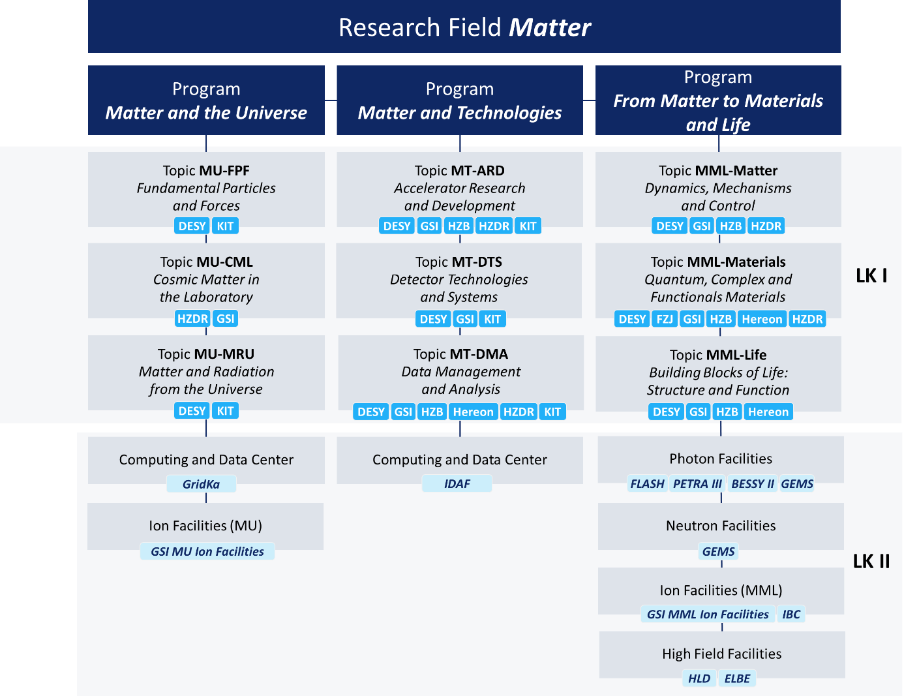
Figure 2: Schematic Overview of the Research Field Matter with its programs, topics, facility topics and LK II for PoF V

  - Role and Impact of infrastructures
The Research Field Matter and its mission are inconceivable without large-scale research infrastructures which work as super-microscopes and -telescopes for the world of the invisibly small and inconceivably large.
The interdisciplinary and cross-sectional research at its large-scale research facilities is the salient feature of Matter. It depends critically on the paradigm of a highly efficient research strategy, developed and executed in cooperation between universities, non-university research institutions and industry. This strategy is centrally dependent on the core competence of the Research Field Matter in the design, construction, and operation of complex large-scale research facilities. To strengthen this competence, the program Matter and Technologies takes up demands and needs from the researchers and users to develop improved accelerators, detectors and data management systems.
Another important point is the necessary modernization of research facilities, which the Research Field is facing in an international environment that is competitive in terms of talent and technology.
The large-scale research facilities in Matter are platforms that play an indispensable role in projects in a broad range of disciplines ranging from physics, chemistry, biology to geo- and materials sciences and medicine, as well as in many other disciplines of societal relevance. They offer unique research opportunities. They open opportunities to our early career scientists, at universities and research centers, to develop their science portfolio and to develop broad networks.
The Research Field in addition operates a number of mid-sized infrastructures. These infrastructures play a central role in the development of new technologies and methods, in a very flexible environment, but often also offer access to a broad range of users including universities and industry.
The potential of non-destructive in-situ, in-vivo, and operando analytics are increasingly being recognized and utilized in industry-related research. In the future, the access by industry to large-scale research facilities will become more and more important, thereby making a significant contribution to the country's technology sovereignty.
A significant part of the international research is supported by large long-term collaborations. This is especially the case in the fields of particle and astroparticle physics. Scientists from all areas in Matter are key partners in the leading international infrastructures, contributing know-how and in-kind, and are much sought after partners in a wide range of projects.

  - Internal and external cooperation
To fulfill its mission and set research objectives, the Research Field Matter relies on the cooperation with partners with complementary skills, including selected representatives of relevant sectors of industry. This will continue to be an essential part of the research strategy in the future.
The structure of the three Matter programs reflects the close cooperation between the participating centers.
Within the Research Field, the three programs are set up in such a way that a maximum degree of cooperation between the centers and with all Helmholtz research fields is promoted (see also 5.5. “Cross cutting topics”).
A decisive factor in its national role are the large research facilities, which the Research Field operates as user facilities, thus providing access annually to more than 10,000 users from the entire scientific system to the complex and dedicated experimental stations and equipment.
Matter closely cooperates with all actors in the German science landscape. Collaboration with universities plays a prominent role. It primarily occurs through scientific collaborations and user operations, as well as through joint appointments of leading scientists and education of doctoral students. Helmholtz Institutes (like HI Jena and HI Mainz) are acting as an interface between centers and universities. Another highlight of this cooperation strategy is the visible success in the German Excellence Initiative. A further important tool is the BMBF “Verbundforschung” program, which enables university groups to contribute to the portfolio of instrumentation at research infrastructures and thus optimally execute their research there.
The Research Field of Matter is deeply interconnected on a European and international scale through its large-scale projects, actively seeking strategic partners worldwide to boost its research objectives. The dramatically changed geopolitical situation requires a critical analysis of cooperations with countries where scientific freedom is threatened or not intact and necessitates an increased focus on technological sovereignty. The Research Field is currently very active in seeking to achieve greater robustness in the interaction with like-minded international partners in the future, with the goal of maintaining targeted win-win cooperations extending from purely scientific exchange to sustainable mutual inspiration with industrial partners.

  - Matter Competence Teams
As a core aspect of its mission, the Research Field Matter delves into fundamental investigations of the structure and function of matter, utilizing advanced large-scale research facilities. The expertise within this research area holds significant importance not only for all Research Fields within the Helmholtz Association but also for the broader scientific community.
To fully unlock this Helmholtz potential, the Research Field is setting up so-called Matter Competence Teams (MCTs) in selected research areas that are distinguished by both a high interdisciplinary character and significant relevance. The tasks of the MCTs are:
- organizing an interdisciplinary Matter platform for the Research Field (“Matter-driven Cross cutting Topics”) and for the Helmholtz association (“Helmholtz-driven Cross cutting Topics”)
- serving as competent contact points both Helmholtz-internally and externally
- identifying so far unexplored cross-cutting projects. A selected part of the funding could be sourced from the Helmholtz Innovation pool funding corridor, specifically earmarked for 3-years “pathfinder projects”.
The MCTs, led by a speaker and co-speaker, will have a lean governance structure.

Table 1: The following MCTs will be established with a streamlined governance structure
Matter Competence Teams | Coordination | Cooperation | Comments
- AMD: Advanced Materials Design | Matter-MML | All fields | Focus on safe and sustainable materials
- OPT: Frontiers of Optical Technologies | Matter-MT | Information AST, Energy | Focus on large and fast laser systems/ sources, X-ray optics
- SRB: Structural and Radiation Biology | Matter-MML | Health, Energy
Helmholtz-driven Cross Cutting Topics | Coordination | Comments
- CR: Matter for Climate Research | Earth and Environment | Matter Competence Teams to connect to the overall Helmholtz Cross Cutting Topics
- QT: Matter for Quantum Technology | Information
- BE: Matter for Biomedical Engineering | Health

  - Commitment to strengthening and advancing our workforce and infrastructures
Strategies on center-related (research) policy and/or structural topics such as innovation and transfer, talent management, sustainability, parity (equal opportunities), diversity, digitalization, etc.
A list of all centers and their activities should be avoided. Rather general (and Research Field-wide) aspects should be described first, which are then substantiated with one or two best-practice examples.
The centers should be in close exchange to fine-tune the examples and ensure that a diverse picture of the activities of the centers of the Research Field is be shown here. In addition, the overarching Matter-perspective should always be considered (and could at best relate to the “grand challenges” of the Research Field Matter in a way).
    - Advancing infrastructures: Photon Science Roadmap
See also annex
    - Talent management and Equal Opportunities and Diversity
xxx
    - Innovation
The Research Field Matter pursues a very active approach to creating and transferring technologies to practical applications. Researchers’ insights, ideas, and solutions are made available for an immediate and lasting impact on society and business as rapidly as possible – whether in the form of innovative materials, new drugs, complex data systems, or high-caliber information services backed up by science.
Active participation in a broad variety of technological networks combined with powerful research and technology infrastructures work hand in hand to provide comprehensive innovation ecosystems within the Research Field Matter. Such ecosystems encourage scientists to think outside the box and make it easy as well as straight forward to advance technologies out of the lab towards commercial products. In this process, scientists directly benefit from individually tailored trainings and personal incentive systems that reward innovative initiatives from the beginning to the end.
The Research Field Matter continuously trains highly skilled technologists who contribute to technological and innovation leadership either in scientific careers with transfer initiatives or within careers outside the science community as managers in commercial enterprises.
    - Knowledge transfer
Research in the research field Matter is highly characterized by international cooperation between different research institutions and often takes place in large international collaborations. These collaborations and the international and diverse environment also in the local research facilities have an integrative effect on the society and can be seeds of far-reaching scientific and economic collaborations. By developing and operating versatile infrastructures, the research field Matter ensures that numerous scientists, engineers, technicians and other specialist personnel in many areas in the infrastructures themselves, but also in the technological and economic environment of these infrastructures, have the expertise they need as individuals and as members of the society for the future.
The research field Matter strives for disseminating its gained knowledge. Already the youngest are addressed in dedicated outreach activities to gain hands-on experiences with scientific experiments and analyses of real, open-access available scientific data and software. The broader society, teachers, and experts within the wider and neighboring communities are invited to participate in multiple outreach formats, up to perform science analyses via open-access data and software portals. The research field Matter promotes individual and societal excellence through highest level of education, training, and quality of research to maintain a world-wide leadership role in research and innovation.
    - Sustainability
In the last years, sustainability in the Research Field Matter has rapidly evolved, has opened up to a much more climate friendly research and has identified the main challenges of the coming years. Main strategic goals are to further strengthen the establishment of sustainability as a fundamental common philosophy/value, both in research for sustainability as well as the sustainable construction and operation of (large-scale) research infrastructures. Sustainability is a strong part of the overall transformation and creates the necessary dynamics in cooperation with digitalization, internationalization, equality, diversity, focus on young scientist, innovation and many more, which are in the end all part of a broad definition of sustainability.
Detailed understanding of the basic constituents of matter allows for groundbreaking insights into the processes of the micro- and macro-cosmos, which in turn provides us the atomic and molecular foundations essential to tackling global challenges in the long run. In the coming years this includes xxx and yyy.
At the same time, the research infrastructures are working flat out to become more and more sustainable themselves. As the enormous amount of materials and energy which is needed to construct and operate RIs show, the Research Field Matter has a specific responsibility for the development and technology transfer of the most efficient technologies. All centers within the Research Field Matter are at the forefront of international sustainability cooperation not only participating in international R&D projects but also shaping the next generation of such projects which is also a strong strategic element for the next PoF-period. Thematic priorities in the sustainability realm are therefore developments in Life Cycle Assessment and behavioral change towards design for sustainability.
    - Digitalization
xxx

- Annex
Table 2: Research infrastructures (user facilities) of the Research Field Matter with prioritized funding scheme in PoF V (so-called LK II – “Leistungskategorie II”)
Acronym | Program | Type | Centers | Annual operating costs (T€) | Thereof: base-funded scientific and technical staff (FTE)
GridKa | MU | Data | KIT | 6,396 | 25.8
Grid Computing Centre Karlsruhe, Tier-1 center
GSI-MU Facilities* (during construction FAIR) | MU | Ion | GSI | 27,658 | 128
UNILAC, SIS18, ESR and FRS with respective experimental sites, delivering ion beams from protons to uranium at up to 4 GeV (p) and 2 GeV/u (U) respectively; facility for production of high intensity radioactive beams and injector for the FAIR accelerators including an IT Compute Facility (Green IT Cube) for data acquisition and analysis
IDAF | MT | Data | DESY | 6,445 | 16.8
Interdisciplinary Data and Analysis Facility for Matter Research
BESSY II | MML | Photon | HZB | 52,000 | 216
Third-generation soft X-ray user facility utilized for accelerator R&D
FLASH | MML | Photon | DESY | 53,391 | 181.3
XUV and soft X-ray free-electron laser, 10% of beam time dedicated to accelerator R&D
PETRA III | MML | Photon | DESY | 82,326 | 291.7
Third-generation synchrotron radiation source with high brilliance, mainly for experiments in the hard and high-energy X-ray range
GEMS | MML | Photon & Neutron | Hereon | 7,065 | 32
German Engineering Materials Science Centre with outstations and instrumentation at DESY (PETRA III) and MLZ (FRM II), including complementary engineering materials science laboratories
Accelerator of European XFEL | MML | Photon | DESY | 132,917 | 311.8
GSI-MML Facilities* (during construction FAIR) | MML | Ion | GSI | 8,651 | 47
HITRAP, CRYRING, ESR for storage and cooling of highly-charged ions; KJ/PW laser PHELIX; various experimental areas for atomic, plasma and biophysics and materials research
IBC | MML | Ion | HZDR | 9,395 | 38.3
Ion beam facility for materials and interdisciplinary research
ELBE (DRACO and PENELOPE) | MML | High-Field | HZDR | 9,861 | 29.6
Multiple radiation source powered by superconducting CW electron LINAC
HLD | MML | High-Field | HZDR | 6,290 | 24.7
High-magnetic-field facility generating highest possible non-destructive pulsed magnetic fields

Table 3: Proposed LK II research infrastructures (user facilities) of the Research Field Matter (Helmholtz Roadmap) under discussion: Personal (2023, grundfinanziert, Wissenschaftler, wiss.-unterst. Personal)
Acronym | Program | Type | Centers | Category | Time period | Total investment in Mio. € | Year of planning
TIER-Upgrade |  |  | KIT, DESY, GSI | A | 2027 - 2030 | 33 | Hier das Jahr der Kostenberechnung angeben
Upgrade of the Grid Computing Centres for the HL-LHC**
PETRA IV |  |  | DESY, Hereon | B | 2024 - 2031ff | 1.400
Upgrade der Synchtrotron-strahlungsquelle PETRA III**
DALI | MML | Photons/  Fields | HZDR | B | 2027 - 2033 | 229 | 2023
Dresden Advanced Light Infra-structure**
BESSY III |  |  | HZB | B | 2029 - 2031ff | 980 | 2021
Berliner Elektronenspeicherring für Synchrotronstrahlung III**
IceCube-Gen2 |  |  | DESY, KIT | C | 2024 - 2031 | 292,2
IceCube-Generation 2**
DARWIN |  |  | KIT | C | 2025 - 2030 | 175
Dark Matter WIMP Search with Liquid Xenon
ET |  |  | DESY, HZDR, KIT | C | 2026-2031ff | 1736
Einstein Telescope, a 3rd Generation Gravitational Wave Detector
GCOS |  |  | KIT | C | 2028 - 2031ff | 390
Global Cosmic Ray Observatory
HIBEF 2.0 |  | Beamline | HZDR, GSI | A* | 2024 - 2026 | 28
Helmholtz International Beamline for Extreme Fields 2.0*

Category A – Helmholtz projects financed through the Helmholtz Association‘s competitive procedure for strategic expansion investments (€15 to €50 million).
Category B – Large national projects of the Helmholtz Association that are included on the national roadmap and funded with additional project funding (> €50 million).
Category C – Helmholtz participation in international research infrastructures that are transferred to the ESFRI list via the national roadmap, via the national representatives,
or include other international participation.
A* – The construction of HIBEF 1.0 at the European XFEL is almost complete, but the withdrawal of the Chinese cooperation partner means a replacement investment is necessary. HIBEF 2.0 is not consider a LK II.
*) New strategic expansion projects already underway before 2021 or approved since 2021 are not listed here.
**) Update compared to the 2021 planning proposal.

Subject to pending international and national funding decisions.
Values are given for the year 2022 as numbers for the year 2023 are not available yet. * During FAIR preparation GSI’s user facilities deliver a reduced amount of beam time, which will increase with the start of FAIR facilities during PoF V.

