Progress Report 2023

Program “Matter and the Universe”

Spokesperson of the Program:

Ralph Engel | Karlsruhe Institute of Technology

**Contents**

0 Preamble Program “Matter and the Universe” 3

1 Program “Matter and the Universe” 4

1.1 Goals and Embedding into the Research Field 4

1.2 Structure 4

1.3 *Optional*: New structural Developments and Changes of Framework 4

2 Scientific Highlights 5

3 Implementation of the program 5

3.1 Implementation of the Senate recommendations 5

3.2 Implementation of specific research policy objectives 5

3.2.1 Topic 1 6

3.2.2 Topic 2 6

3.2.3 Topic 3 6

4 Strategic Topics 7

4.1 Talent Management 7

4.2 Networking and Cooperation 7

4.3 Transfer in Economy and Society 7

4.4 Third-Party Funding 7

4.5 Research Infrastructure 7

5 Indicators and Resources 9

5.1 Quantitative Indicators 9

5.2 Development of Costs 10

Associated Research Infrastructures (LK II) 11

1 Research Infrastructure XXX 11

1.1 Recommendations of the Senate 11

1.2 Indicators and Resources 11

0 Preamble Program “Matter and the Universe”

As we reach the mid-term point of the fourth program period, this progress report will present highlights and special events in 2023 as well as a brief interim resume of the achievement of the research policy objectives.

The research policy objectives formed the starting point and the framework for the design of the three programs of the Research Field Matter for the Helmholtz Association's fourth program period. Overarching goals in the research field Matter and their implementation are presented in the progress report of the coordinator of the research field.

Chapter 1 of the following program report describes the global research objectives, the embedding in the research field and the program structure. Structural developments and changes in the framework conditions compared to the original research policy objectives and program goals are outlined.

Chapter 2 presents scientific highlights for the year 2023.

Chapter 3 presents the status of implementation of the Senate's recommendations on cross-program activities, followed by an interim resume of the implementation status of the specific research policy objectives at topic level.

Chapter 4 describes overarching activities and the strategic topics (which the Senate of the Helmholtz Association considers to be of paramount importance). Both chapters directly address the research policy objectives on structural goals and joint initiatives of the research field on cross-divisional activities, for example on talent management, networking, transfer to industry and society, acquisition of third-party funding and research infrastructures. With regard to the latter, the specific research policy objectives are also mentioned, an interim resume of the implementation status is provided.

Chapter 5 shows the key performance parameters that quantify progress based on standardized scales.

This is followed by a report on the status of the large-scale research infrastructures associated with the program also with regard to the original research policy objectives.

1 Program “Matter and the Universe”

*Throughout the document, please format the text in Arial, font size 10, line spacing 1.15, justified text, and use inclusive language.*

1.1 Goals and Embedding into the Research Field

*Please briefly explain the goals and strategy of the program (approx. ½ page).*

Goals of the program are the identification of fundamental particles and their interactions as well as to obtain an exact understanding of the structure of the vacuum; strengthening the understanding of the structure and dynamics of hadrons, nuclei and nuclear matter and their role in the astrophysical formation of chemical elements; strengthening the understanding of the nature of Dark Matter and Dark Energy and of the universe at high energies.

1.2 Structure

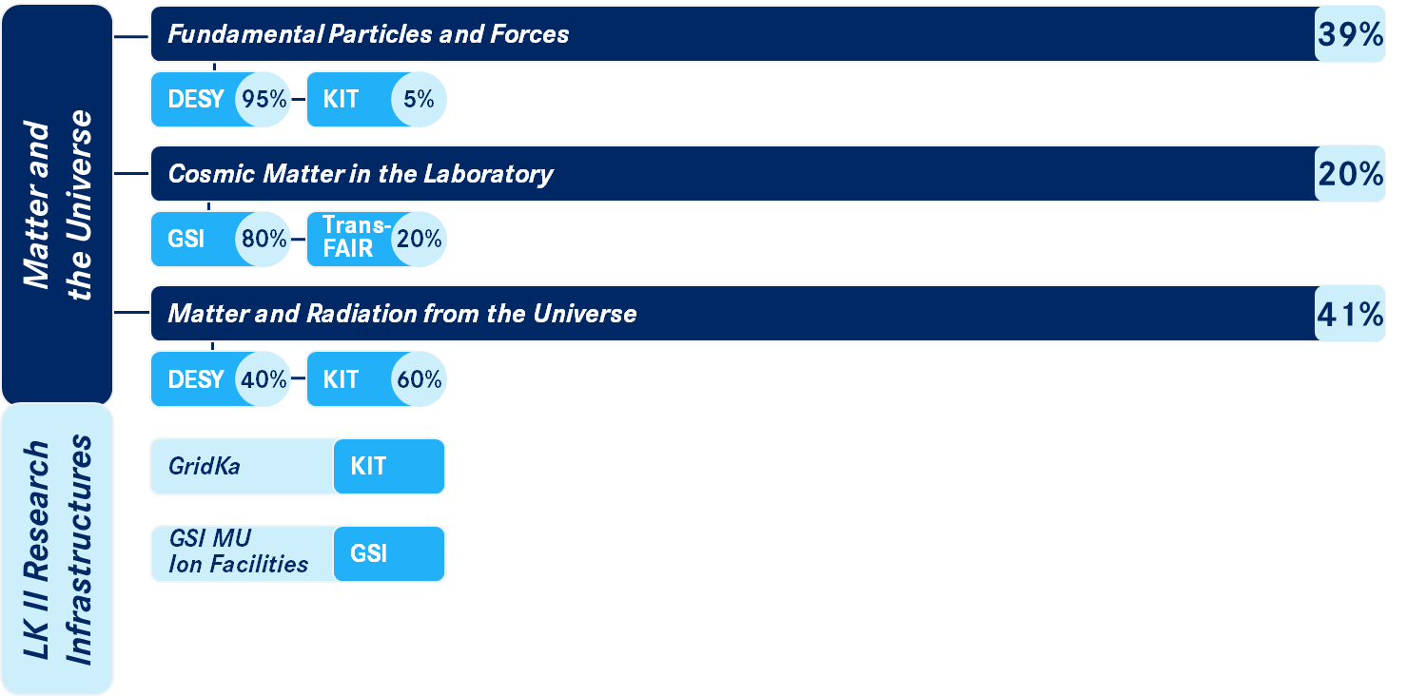*If the program structure has changed within the reporting year (topic abandoned, newly taken up or renamed), this should please be briefly explained.*

The program XXX is structured as follows:

Topic 1: YYY  
(spokesperson: [name])

*Concise description (2-3 sentences)*

Topic 2: YYY  
(spokesperson: [name])

*Concise description (2-3 sentences)*

1.3 *Optional*: New structural Developments and Changes of Framework

*OPTIONAL SECTION. Explain adjustments to the original program planning for the future reporting period that have resulted from structural developments and changes of framework (e.g. additional associated partners, different funding, founding or closing of institutes) in the implementation of the program, as well as their effects on the implementation of recommendations of the Senate, if applicable. Describe any necessary deviations in content from the original program planning and/‌or difficulties in its implementation. Comment on possible impacts on the achievement of goals within the strategic guideline.*

2 Scientific Highlights

*Please present* ***one to a maximum of two*** *scientific highlights of the program or the individual topics of the past year that are of particular strategic relevance. These should be presented briefly (max. 1 page per topic) and can be supported by a few selected publications, prizes, etc.*

*Please format the list of cited publications in font size 9, line spacing 1, special indentation hanging by 0.75, spacing before the paragraph 3 pt. and justified – like this paragraph. Please indicate the authors involved in the program in bold or via an author index that illustrates the affiliation at the topic level (e.g.: 1 Topic 1, 2 Topic 2, 3 Topic 3, 4 Topic 4, * other institutions).*

Highlight 1:

Highlight 2:

3 Implementation of the program

3.1 Implementation of the Senate recommendations

*Please comment on the implementation of the Senate recommendations and the specific goals of the strategic guidelines (see below). Name concrete steps for the implementation of the recommendation Reporting is done at the level (program or topic) to which the respective recommendation or goal relates.*

The Senate of the Helmholtz Association provides the following specific recommendations at the level of the Research Program at LK I:

The strong leadership position of Helmholtz in the global field should be fully supported.

...

Retain some degree of flexibility for adjustments over the period of PoF IV.

...

Nurture the novel idea for EDM determination in COSY.

...

Continue to clarify the TransFAIR (FZJ/GSI) evolution.

...

Consider participation in future global initiatives in gravitational wave observations e.g. the Einstein Telescope.

...

Enhance coordination of theoretical and experimental approaches across the program.

...

Execute the FAIR Phase-0 program with a continuous management of the work force. With the use of FAIR Phase-0, accomplish smooth transition from old to new facilities at GSI.

...

3.2 Implementation of specific research policy objectives

The following section lists the specific research policy objectives at the level of the Topics and provides an interim resume on the implementation:

*Please comment briefly on the implementation of the topic-specific objectives from the research policy objectives. Who is responsible and which centers have worked on the objective? What was achieved (brief description with a focus on highlights / key points)? Which indicators underpin the results? What obstacles existed and still exist? What is still open? How and on what timetable is work being carried out? Is there a need for adjustment in the formulation of objectives?*

3.2.1 Topic 1

Core statements of the research policy target agreements 1, 2, ...:

Accurate measurements of the properties of the Higgs boson will be carried out at LHC/HL-LHC, as well as high-precision investigations of the electroweak and strong interaction at LHC/HL-LHC and at Belle II. Search with these experiment for new particles and phenomena, either by direct observation or by deviations between theory and precision measurements.

...

Search for axions and similar hypothetical particles with the ALPS II experiment at DESY. In addition, the technical and financial feasibility of the possible follow-up projects, MADMAX and IAXO, will be worked out and possibly lead to first demonstrators.

...

Advance the understanding of cosmology, illuminate the so-to-speak “dark side” of the universe, and are complementary to astroparticle physics activities in the topic 3.

...

3.2.2 Topic 2

Core statements of the research policy target agreements 1, 2, ...:

Investigate the phase diagram of hot and dense nuclear matter with their effect on the equation of state of astrophysical objects such as supernovae, neutron stars, and merging neutron stars. This may also lead to new insights into gravitational wave signals.

...

Investigate the nuclear structure and the reaction phenomena far away from the so-called valley of stability. In particular, a better understanding of the element formation in the universe in supernovae and neutron star fusions should follow from the study of the r-process, e.g., the element abundances of the elements gold, platinum, and beyond.

...

Test QCD predictions for exotic particle states via precision measurements of proton-antiproton collisions.

...

3.2.3 Topic 3

Core statements of the research policy target agreements 1, 2, ...:

Gain a comprehensive understanding of the structure of the universe as a whole, derived from the observations of the various complementary messengers (gamma radiation, neutrinos, particles and nuclei, and gravitational waves). The Research Field will strengthen this so-called multi-messenger approach significantly during the PoF IV period.

...

Integrate existing and future observatory data into a data and analysis center for high-energy astroparticle physics.

...

Measure the mass or the most stringent limitation of the mass of the electron neutrinos with the KATRIN experiment by the end of the PoF IV period. Investigate the feasibility of a corresponding campaign to search for Dark Matter with KATRIN.

...

4 Strategic Topics

*OPTIONAL: Because the following strategic topics are mostly addressed at the individual center level, they are assigned as standard to the Report of the Research Field Coodinator. Therefore, this chapter is optional for programs; you may report below on specific progress on these topics for the program if they are not already covered in the coordinator report.*

*Note: For the PAKT report, a query on these aspects (best minds, national and international networking, research infrastructures, transfer) already takes place at the center level, which is merged accordingly for the report at the Helmholtz level. Apply the (updated) building blocks if possible. A comprehensive report is not necessary.*

4.1 Talent Management

*Present aspects of talent management (recruitment, career paths, qualification, equal opportunities) at the program level as a supplement.*

4.2 Networking and Cooperation

*Present aspects of networking at the program level as a supplement.*

4.3 Transfer in Economy and Society

*This involves a qualitative presentation of the impact that the research achievements have had beyond the academic communities into the economy and society. Please describe this impact - if possible - along an* [impact chain](https://www.social-impact-navigator.org/): *input (resources invested) – output (services rendered) – outcome (effects at the level of the target group) – impact (effects at the economic or societal level).*

*Illustrate the transfer with a few examples from the centers and assign them to one of the three impact categories:*

* *Technology transfer*
* *Knowledge for decision makers*
* *Knowledge for stakeholders*

4.4 Third-Party Funding

*Examples of important projects acquired (funded by, e.g., BMBF, BMWK, DFG, Industry, EU incl. ERC-Grants)*

4.5 Research Infrastructure

*Report on developments to be highlighted in*

* *Strategy processes for the integration of the FIS into national and international networks*
* *"Life Cycle" management of the RI (exchange with user groups and industry partners, plans for "Science Case" and "Industrial Case" etc.)*
* *Strategies for dealing with the opportunities and risks of digital transformation for FIS ("remote" operation, data access, cyber security, AI, etc.)*
* *Measures to increase the use of existing assets by industry partners or to increase technology transfer (liason officer, plug and play service for industry partners, etc.)*
* *Developments in public involvement in planning, construction, and operation of RI (public outreach, knowledge transfer, etc.).*

*Note: For the PAKT report, the same query already takes place at the center level, which is merged accordingly for the Helmholtz-level report. Apply the (updated) building blocks if possible. A comprehensive report is not necessary.*

Finally, the specific research policy objectives on the research infrastructures at topic level are mentioned and an interim resume of the status of implementation is drawn up, in detail:

Provide large-scale research facilities for users at GSI/FAIR affiliated with the MU program including the UNILAC, SIS18, and FSR accelerator facilities as well as the FAIR Green IT Cube.

...

Operate the German Tier data centers for the LHC experiments, for Belle, and other consortia in particle and astroparticle physics (see the program MT).

...

In particular, develop GridKa to be able to cope with the significantly higher data flows from the HL-LHC.

...

Address additional challenges for the large-scale research infrastructures used within the program, e. g. the high luminosity upgrade of the LHC, novel sensors and detector systems, the Gamma Observatory at CTA, the IAXO experiment, the IceCube-Gen2 interdisciplinary neutrino observatory, the GCOS Global Cosmic Ray Observatory, the AugerPrime upgrade, and the DARWIN project.

...

5 Indicators and Resources

5.1 Quantitative Indicators

Comments:

example

*Please explain and comment on developments/changes in each indicator.*

Publications:

Third-party funding:

Finished dissertations:

Core-funded scientists:

Third-party funded scientists:

5.2 Development of Costs



example

Comments:

*Please comment on deviations of actual costs from Senate recommendations. Deviations > 20% require a vote by the Senate and a comment is mandatory.*

Forschungszentrum X

Forschungszentrum Y

Forschungszentrum Z

Associated Research Infrastructures (LK II)

1 Research Infrastructure XXX

*Please briefly describe the scientific infrastructure and its benefits as well as technical developments in the reporting year (max. 0.5 pages).*

1.1 Recommendations of the Senate

*Please comment on the implementation of the Senate recommendations and the specific goals of the strategic guidelines (see below). Name concrete steps for the implementation of the recommendation. The status of implementation of the recommendations should be indicated by means of concrete criteria/‌indicators.*

The Senate agrees with the very positive evaluation of the LK II infrastructure Tier-1 data and computing center GridKa and approves its funding with an according increase of 2% adjusted full-cost accounting planning.

The funding of the Research Field associated User Facility at GSI (UNILAC, SIS18, FRS, ESR etc.), which is in reduced operating mode, is organized by a dedicated agreement of the Helmholtz Association and GSI, and can be assigned in total or parts as a LK II facility in PoF IV, given fulfilled criteria for that.

1.2 Indicators and Resources

1.2.1 Quantitative Indicators

**KENNZAHLENTABELLE ZU DER FIS-1**

Comments:

*Please explain and comment on developments/changes in each indicator.*

Availability

Utilization

Publications

Core-funded scientists

1.2.2 Resources

**RESSOURCENTABELLE ZU DER FIS-1**

Comment

*Please comment on deviations of actual costs from Senate recommendations.*