Travel information

How to reach Catania airport and the historic downtown area
Catania can be easily reached by air or train transportation. We recommend air transportation to the Catania International Airport (airport code CTA), served by several major and low cost companies.
Once at the airport, you can reach the historic downtown by means of the Bus service called ALIBUS, run by the AMTS company. You can find a picture of an ALIBUS at this link. The time schedule ("Feriale" stands for Monday-Saturday, while "Festivo" stands for Sunday) can be found at this link. The route ("percorso") and timetable ("orario") of the ALIBUS is displayed at this link.
The price of the ALIBUS ticket is 4 Euros and it can be purchased outside the Arrival area at small ticket boxes. It is also possible to purchase it also directly at the bus driver. Ask about the "ALIBUS ticket".
Of course you can take a TAXI from the airport to the downtown. Price can vary according to company; best fee (20€) is provided by RadioTaxi, that you have to call by phone (+39 095330966) asking for a ride from airport, asking to pick up you outside of airport first floor - departures zone.

How to reach the venue of the Conference
The Conference will be held at the Dipartimento di Fisica ed Astronomia (DFA) of the Università degli Studi di Catania, and at the INFN - Laboratori Nazionali del Sud (LNS), located inside and aside of the University Campus “Cittadella Universitaria” respectively, with two different close entrances (address: Via Santa Sofia 64 and 62).
The campus of the Cittadella Universitaria can be easily reached by public transportation from downtown Catania. There two options:
1) take the BRT1 bus in downtown Catania and get off at the Cittadella Ovest stop (recommended option). You can find the route ("percorso") and the timetable ("orario") of BRT1 at this link. We recommend this option as the simplest one.
2) take the Metro line in downtown with direction ”NESIMA” and get off at the stop "Milo", where a shuttle bus (labelled FCE) will take you to the Cittadella Universitaria. For that you need to take FCE buses with direction “Catania” or “Parcheggio Santa Sofia”, getting off at the 1st stop of Via Santa Sofia. The same ticket is valid for, both, Metro and the shuttle bus. You can find a route map of the Metro at this link. In case the shuttle bus is delayed, you can walk to the closest BRT1 stop (see option 1), also called "Milo", which is about 100 m away: here you find a map of the Metro stop Milo and the BRT1 stop Milo.
Tickets for both BRT1 or Metro (please note they are different tickets) may be purchased at Newspaper or Tobacco kiosks. Metro ticket may be purchased also at automatic machines inside the Metro. Usually these places have a label AMT indicating that they sell those tickets. In any case, you may ask. The price of one tickets is 1 Euro and it lasts 90 minutes starting on validation time.
Once you reach the "Cittadella Ovest" bus stop, you can walk to the LNS and Campus entrance (see map below and conference venue page)
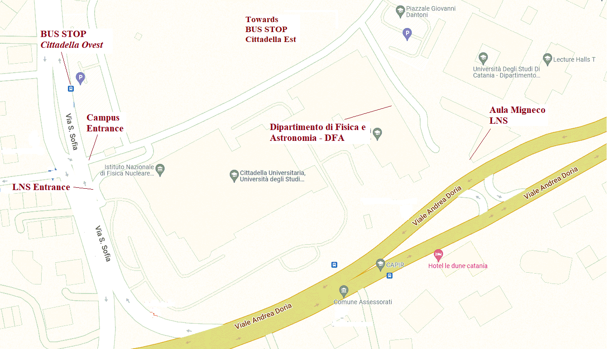
In order to go back to city center, you can walk up to the opposite entrance of the campus and take the BRT1 at bus stop “Cittadella Est”, going downtown Catania, or just walk to the end of “Via Etnea”, where there is a bus stop with also other buses, most of them driving you downtown; see following map for the routes from campus to the two destinations.
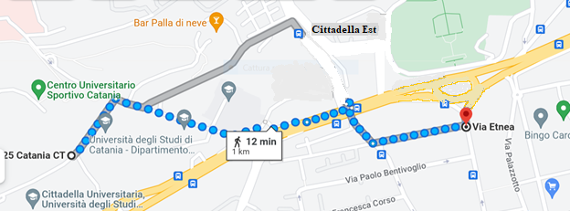

However, here is a google map with the points of interest
R3B Collaboration Meeting Map - https://www.google.com/maps/d/viewer?mid=1AthR8eNsPQ2rA4LjqrPSzzmQtp8ILek&hl=it&usp=sharing

Conference venues
The conference will be held at two different locations:
- November 15, 16 and 17 (Tuesday to Thursday) at "Aula Migneco" of the INFN - Laboratori Nazionali del Sud (LNS)
Address: Via Santa Sofia, 62 (Catania)
- November 18 (Friday) at "Conference Hall" of the – Dipartimento di Fisica e Astronomia "E. Majorana" (DFA) of the University of Catania.
Address: University Campus Cittadella Universitaria, Via Santa Sofia, 64 (Catania)
If you are coming by bus, the bus stop is the same for both locations (see travel information details), and the entrance of the LNS is just before the entrance of the University Campus on Via Santa Sofia.
In order to reach the "Aula Migneco", you need to enter the main LNS entrance, turn right and follow the road. The conference hall "Aula Migneco" is located inside the LNS Guest House building. A few signs will help you reach the place.
In order to reach the DFA you need to enter the campus, walk for about 150 m and turn right down up to the entrance of the building. The "Conference Hall” is located in the floor zero, in the left wing with respect to the main entrance.
The picture below shows how to reach the two locations starting from bus stop.
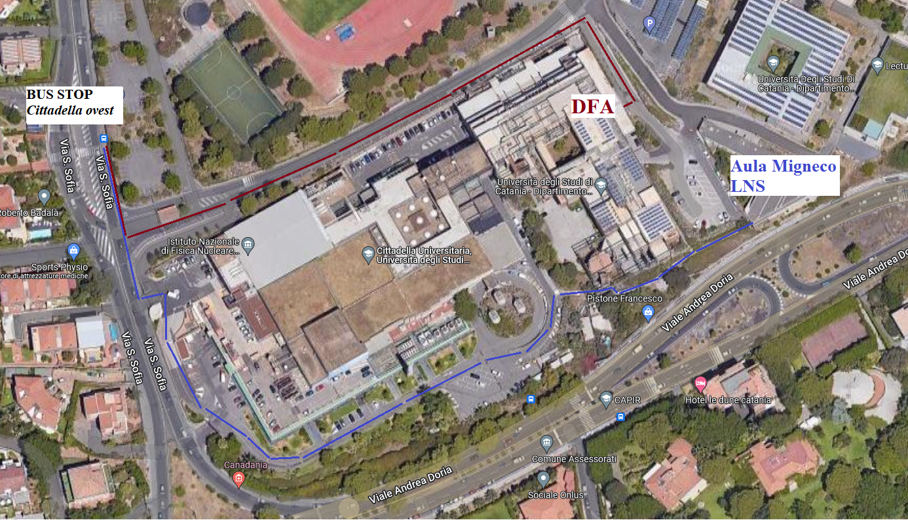

Accommodation
There are some hotels not far from the conference venue, but they are not all easily accessible from the campus, and they are far from downtown, where most of restaurant and shops are located.
Downtown in Catania there are lots of hotels and bed and breakfast; the more practical sites are located near the BRT1 bus stops (see Travel Information), namely close to the Via Etnea, between “Piazza Stesicoro” and “Viale XX Settembre”.

