The NOνA Experiment

Ralf Ehrlich (ehrlich@virginia.edu) for the NOνA collaboration
Department of Physics, University of Virginia, Charlottesville, VA, USA

Abstract

NOνA is a long-baseline neutrino experiment designed to study $ν_{μ}⟶ν_{e}$ and ${\overline{ν}}_{μ}⟶{\overline{ν}}_{e}$ oscillations. It will measure the neutrino mixing angles $θ_{13}$ and $θ_{23}$ with high precision, probe the neutrino mass hierarchy, and search for CP violation in neutrino oscillations. The experiment consists of two detectors. The Near Detector will be located at Fermilab close to the source of the neutrino beam. The Far Detector is being built at Ash River in northern Minnesota. It is positioned 14 mrad off the neutrino beam axis where the neutrinos have an energy distribution with a narrow peak around 2 GeV, and where the transition probability of $ν_{μ}⟶ν_{e}$ is close to its maximum.

Keywords: NOνA, neutrino oscillation, mass hierarchy, CP violation

Introduction

Neutrino physics is currently one of the most exciting topics in particle physics. Even though enormous progress has been made in this area during the past decade, the journey has just begun. There are still many open questions related to the nature of the neutrino itself, but also fundamental questions about the universe for which neutrinos may provide the answer. The NOνA experiment’s goal is to answer some of these questions. The topics where NOνA wants to advance our knowledge include the neutrino mixing angles $θ_{13}$ and $θ_{23}$, the mass hierarchy of the neutrinos, and the CP-violating complex phase in the neutrino mixing matrix.

The name of the experiment – NOνA – stands for NuMI Off axis $ν_{e}$ Appearance, where NuMI is the abbreviation for Neutrinos at the Main Injector. The parts of this name will be explained in the next chapters. The NOνA experiment is an accelerator based neutrino experiment, which consists of two detectors. The neutrino source produces a beam of muon neutrinos and is located at Fermilab. The Near Detector will be situated at Fermilab as well, while the Far Detector is being built 810 km away at Ash River in northern Minnesota. Both detectors are designed specifically to detect electron neutrinos, so that the experiment can study the $ν_{μ}⟶ν_{e}$ and ${\overline{ν}}_{μ}⟶{\overline{ν}}_{e}$ oscillations. The results will be used to answer the above mentioned questions.

The Neutrino Source

The neutrino source for NOνA’s muon neutrino beam is at the Main Injector at Fermilab (NuMI). 120 GeV protons are extracted from the Main Injector ring and fired onto a graphite target. This results in the production of charged pions (and also kaons). The beam of charged pions is focused with the help of two magnetic horns, and is directed towards the Soudan Mine in Minnesota, which is the location of the MINOS Far Detector. The positive (negative) pions quickly decay into anti-muons (muons) and muon neutrinos (anti-muon neutrinos), which happens in the decay pipe which sits directly behind the magnetic horns. While the muons get absorbed, the neutrinos continue on their path with a direction which is close to the direction of the focused pion beam. Depending on the sign of the horn current, either the negatively charged pions or the positively charged pions are focused, so that the experiment can be operated in either neutrino or anti-neutrino mode.

NuMI is currently shut down for an upgrade. When it returns in April 2013, it will be able to deliver $4.9∙{10}^{13}$ protons every 1.3 s in a 10 μs-long spill. It will have a beam power of 700 kW, which is more than twice than the 300 kW before the shutdown.

The Detectors

The NOνA detectors are finely grained to enhance their ability to detect the signals left by electron neutrinos. Their overall design is identical – except their size. They are made of plastic cells with a dimension of 4.0 cm × 6.7 cm × 15 m (the Near Detector cells are shorter). One detector module is formed by 32 of these cells. These modules are arranged in alternating horizontal and vertical planes to enable a 3D reconstruction of the particle tracks. The cells are filled with liquid scintillator which is composed of mineral oil (the solvent), pseudocumene (the scintillant), waveshifters, and an anti-static agent. This scintillator emits light if a charged particle (e.g. from a neutrino interaction with matter) passes through. Some light gets captured by a wavelength shifting optical fiber in each cell. These optical fibers have a diameter of 0.7 mm.1 They transmit the light to avalanche photo diodes (APDs) which sit at one end of each module. The APDs have an 85% quantum efficiency and are operated at ~ 425 V. They are cooled to a temperature of –15 ºC , which is achieved by thermoelectric coolers.

In the spring of 2011, the construction of a fully functioning prototype of the Near Detector was completed. It is located on the surface (unlike the real Near Detector which will be underground) at Fermilab, and is about 1 km away from the NuMI target. Its main purpose is to gain experience before building the Near and Far Detectors. It has a size of 3 m × 4 m × 14 m, has a weight of 222 tons, and consists of 16,000 cells. Due to the relatively short length of the detector in the direction of the neutrino beam, it has a muon catcher on the downstream end. The muon catcher is made of steel planes which are put in between the detector planes. The steel causes muons produced by muon neutrino interactions to range out so that their energy can be estimated. This prototype detector has not only been invaluable for prototyping the equipment and setting up procedures to build the other detectors, but also for developing reconstruction algorithms.

The real Near Detector will be built underground in a cavern at Fermilab, and will also be approximately 1 km away from the NuMI target. Its dimensions will be 4 m × 4 m × 14 m, with a weight of 266 tons, consisting of 20,000 cells. Just like the prototype detector, it will have a muon catcher. The Near Detector will be used to measure the muon neutrino flux emitted at the source of the neutrino beam. It is also needed to study background events, such as electron neutrino contaminations of the neutrino beam and neutral current events being misidentified as charged electron neutrino interactions.

The NOνA Far Detector (Figure 1) is being built in northern Minnesota 810 km away from the NuMI target. The construction of the first detector block began in the summer of 2012, and the first data will be acquired as soon as the first two blocks have been installed. The first oscillation events will be observed when the neutrino beam is turned on in April 2013 while the detector is still being constructed. When it is completed in April 2014, it will consist of 356,000 cells, have a weight of 14 kt, and a size of 15 m × 15 m × 63 m. It is designed to study electron neutrinos after they oscillated from muon neutrinos coming from Fermilab’s neutrino beam.

The Near and Far Detectors are located 14 mrad away from the beam axis. At this angle, the neutrino beam has a narrow energy distribution with a peak at 2 GeV (Figure 2). With this narrow distribution, it was possible to find a Far Detector location which is close to the $ν_{μ}⟶ν_{e}$ oscillation maxima of the majority of the neutrinos. This narrow peak also helps to reduce the background to the $ν_{e}$ appearance signal from incompletely reconstructed higher energy $ν_{μ}$ interactions.

The NOνA detectors are designed to make it possible to distinguish different neutrinos and neutrino interaction types (Figure 3). For example, charged-current $ν_{μ}$ interactions can be easily identified by a long muon track. On the other hand, charged-current $ν_{e}$ interactions will lead to short electron tracks with EM cascades along the track. Neutral current events often produce neutral pions, which decay into $π^{0}⟶γγ$. These types of events can be identified by a gap between the interaction vertex and the electromagnetic shower. Short proton tracks and hadronic cascades around the interaction vertices may be visible in both interaction types.

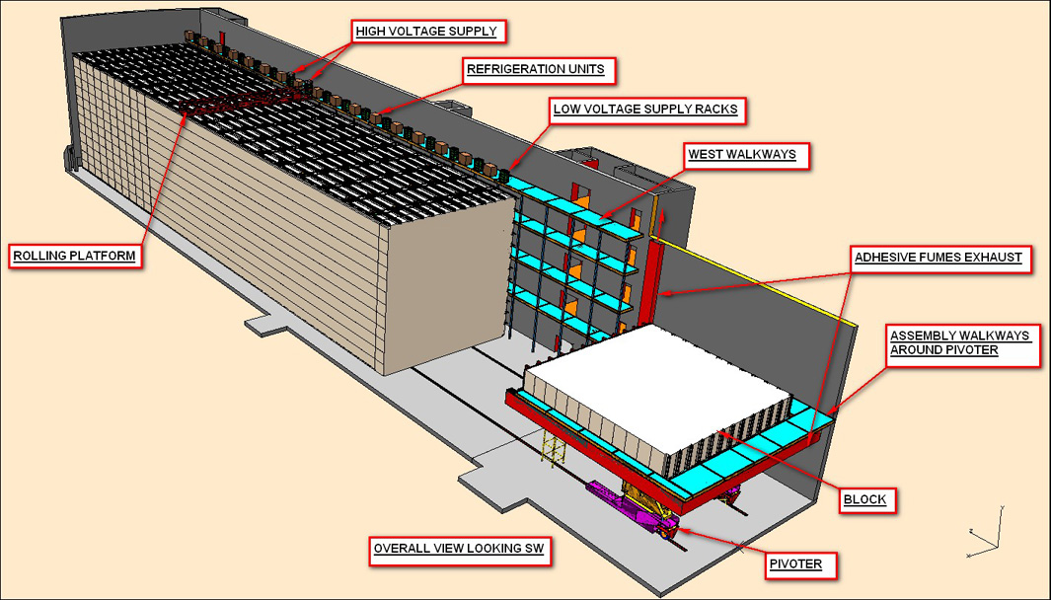
Figure 1: A schematic of the NOνA Far Detector showing the block pivoter used for fabrication.
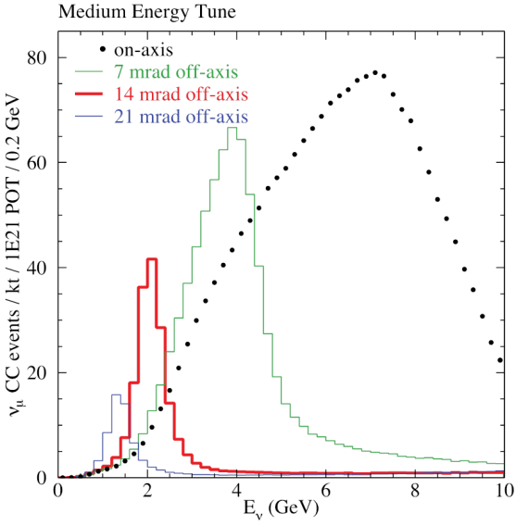 | 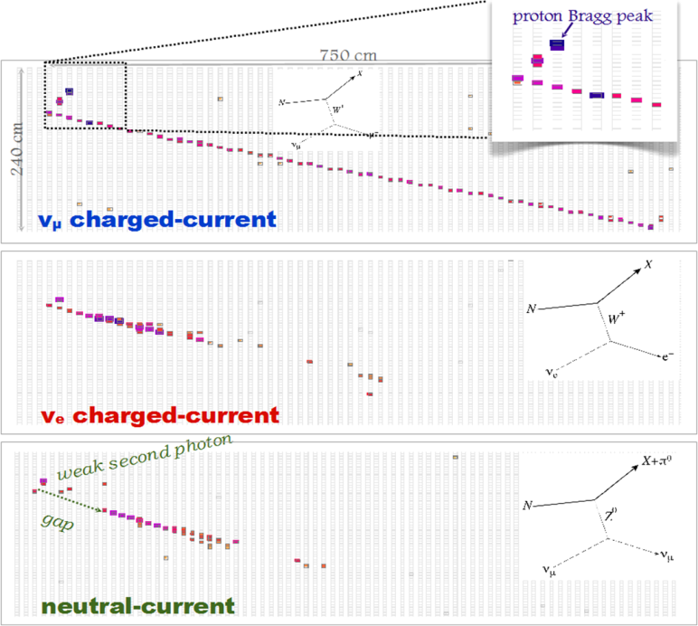
Figure 2: The neutrino energy spectrum for different off-axis angles. | Figure 3: Typical (simulated) neutrino interaction events in the NOνA Far Detector.

The Neutrino Mixing Parameters

The current status of the neutrino mixing parameters are listed in Table 1.3 These numbers include the most recent measurements from reactor neutrino experiments. One can see that one of the open questions is the unknown sign of $Δm_{31}^{2}$ since we do not know the mass hierarchy. The complex CP-violating phase δ in the neutrino mixing matrix is unknown as well. CP violation has only been found in the quark sector. The neutrino mixing angles $θ_{13}$ and $θ_{23}$ – which are relevant for NOνA – have been measured to a relatively high precision during the past couple of years. However, NOνA should be able to improve their precision even further. In particular, it is of great interest to know whether $θ_{23}$ is exactly 45º, and if not, whether it is less or more than 45º.

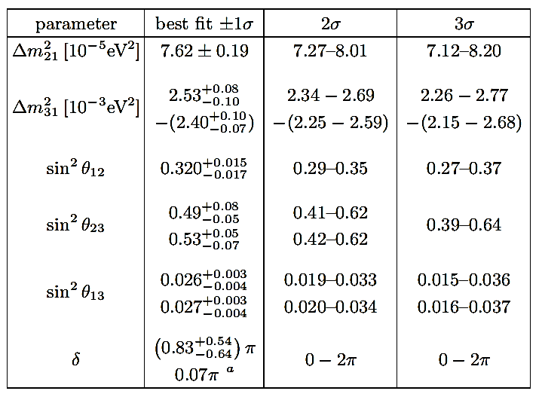
Table 1: Neutrino oscillation parameters. For $Δm_{31}^{2}$, $\sin^{2}\left(θ_{23}\right)$, $\sin^{2}\left(θ_{13}\right)$ and δ the upper (lower) row corresponds to normal (inverted) neutrino mass hierarchy.
Measuring the appearance of $ν_{e}$ and ${\overline{ν}}_{e}$ is equivalent to determining the oscillation probabilities $P\left(ν_{μ}⟶ν_{e}\right)$ and $P\left({\overline{ν}}_{μ}⟶{\overline{ν}}_{e}\right)$. The probabilities $P$ are functions of the mixing angles $θ_{13}$, $θ_{23}$, $θ_{12}$, the CP-violating phase δ, the mass hierarchy (i.e. normal or inverted), and the mass-squared differences $Δm_{31}^{2}$, $Δm_{21}^{2}$, $Δm_{32}^{2}$. The probabilities also depend on the neutrino energy (which is distributed around a peak of 2 GeV), and the oscillation distance (810 km). Additionally, the matter effect needs to be taken into consideration. The presence of electrons along the path of the neutrino beam, and the charged-current scattering of electron neutrinos on these electrons lead to neutrino mass eigenstates and mixing angles which are different than the vacuum mass eigenstates and mixing angles. This results in different oscillation probabilities.

An approximation of the oscillation probability is given below:2,

$P_{vac}\left(\begin{matrix}ν_{μ}→ν_{e} \\ {\overline{ν}}_{μ}→{\overline{ν}}_{e}\end{matrix}\right)≈\sin^{2}\left(θ_{23}\right)\sin^{2}\left(2θ_{13}\right)\sin^{2}\left(∆_{31}\right)$  $+\cos^{2}\left(θ_{13}\right)\cos^{2}\left(θ_{23}\right)\sin^{2}\left(2θ_{12}\right)\sin^{2}\left(∆_{21}\right)$  $+Jsin\left(∆_{21}\right)sin\left(∆_{31}\right)\left[cos\left(∆_{32}\right)cos\left(δ\right)∓sin\left(∆_{32}\right)sin\left(δ\right)\right]$, | (1)

where

$∆_{ij}=1.27\frac{Δm_{ij}^{2}L}{E}$ with $∆m_{ij}$ in ${eV}^{2}$, $L$ in $km$, and $E$ in $GeV$, | (2)

and

$J=cos\left(θ_{13}\right)sin\left(θ_{12}\right)sin\left(θ_{13}\right)sin\left(θ_{23}\right)$. | (3)

The matter effect modifies Equation (1):4

$P_{matter}\left(\begin{matrix}ν_{μ}→ν_{e} \\ {\overline{ν}}_{μ}→{\overline{ν}}_{e}\end{matrix}\right)≈\left(1±\frac{E}{6Gev}\right)P_{vac}\left(\begin{matrix}ν_{μ}→ν_{e} \\ {\overline{ν}}_{μ}→{\overline{ν}}_{e}\end{matrix}\right)$. | (4)

The $±$ sign in Equation (4) gets reversed for the inverted mass hierarchy. For a normal mass hierarchy, the oscillation probability gets enhanced for electron neutrinos; for an inverted mass hierarchy, the oscillation probability gets enhanced for anti-electron neutrinos.

As mentioned above, NOνA measures the appearance probabilities for $ν_{e}$ and ${\overline{ν}}_{e}$. It is expected that the experiment will run at least three years in the neutrino mode, and three years in the anti-neutrino mode. Figure 4 shows how one may be able to extract $θ_{13}$, the mass hierarchy and the CP-violating complex phase δ from the measured probabilities. For a fixed $θ_{13}$ and mass hierarchy, the probabilities $P\left(ν_{e}\right)$ and $P\left({\overline{ν}}_{e}\right)$ are a function of δ, producing the ellipses shown in Figure 4. This procedure can be repeated for different $θ_{13}$ and for both mass hierarchies. After a probability pair has been measured, it can be used to determine the values of $θ_{13}$, δ, and the mass hierarchy (see Figure 5). The ellipses of both mass hierarchies overlap for certain values of δ. Note, that these contours will look different, if $sin\left(2θ_{23}\right)<1$. The significance plots in Figure 6 and Figure 7 indicate how well NOνA will resolve the mass hierarchy and determine the CP-violating phase depending on the values of δ.

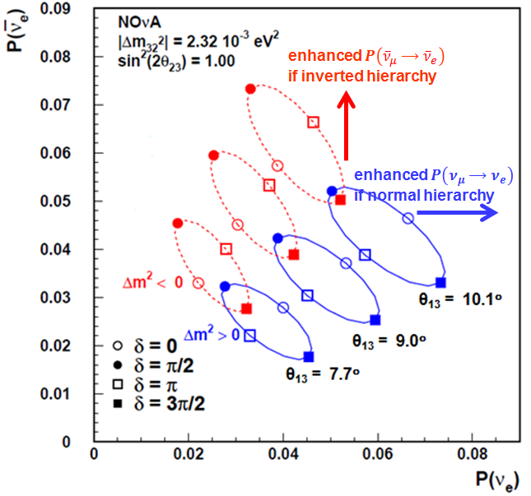 | 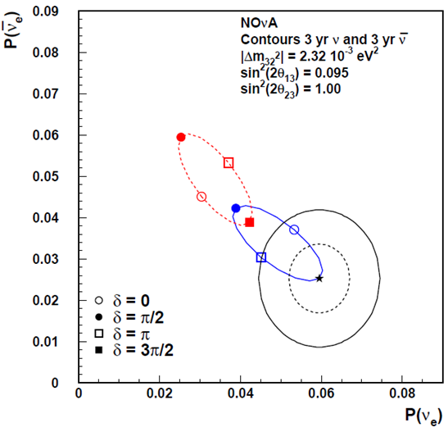
Figure 4: $P\left(ν_{e}\right)$-$P\left({\overline{ν}}_{e}\right)$ probability plot. The favored value of $θ_{13}$ is 9º. | Figure 5: 1σ and 2σ contours for starred point.

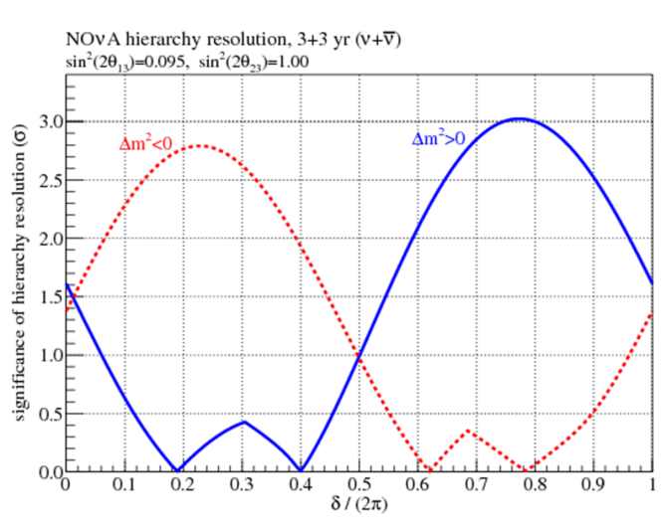 | 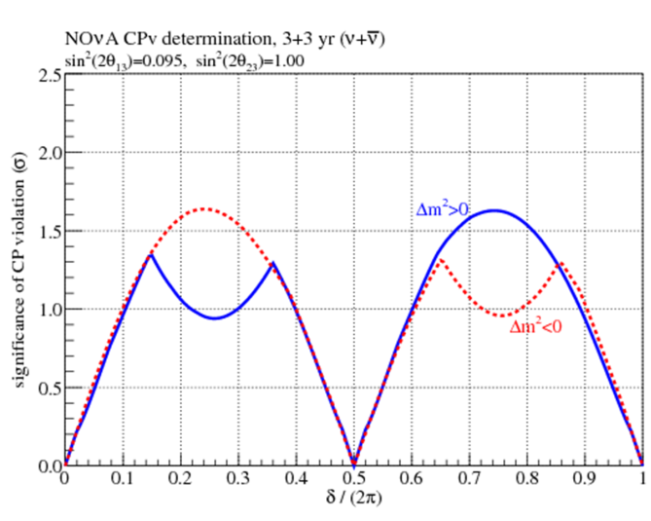
Figure 6: Significance of resolving the mass hierarchy. | Figure 7: Significance of determining the CP-violating phase.

Two more parameters – $θ_{23}$ and $Δm_{32}^{2}$ – can be measured by looking at the $ν_{μ}$ survival probability, which can be approximated by Equation (5).

$P\left(ν_{μ}→ν_{μ}\right)≈1-\sin^{2}\left(2θ_{23}\right)\sin^{2}\left(∆_{32}\right)$, | (5)

where

$∆_{ij}=1.27\frac{Δm_{ij}^{2}L}{E} with ∆m_{ij} in {eV}^{2}, L in km, and E in GeV$. | (6)

This approximation uses the fact that the $ν_{μ}$ disappearance is dominated by $ν_{μ}→ν_{τ}$ oscillations. The disappearance probability $P$ depends on $θ_{23}$, $Δm_{32}^{2}$, the oscillation length $L$, and the neutrino energy $E$. The probability $P$ needs to be measured for several energy bins at the Near Detector and Far Detector. With the known value of $L$ (810 km) and several probability-energy pairs, it is possible to obtain values for the two unknown variables $θ_{23}$ and $Δm_{32}^{2}$. This requires an excellent energy resolution for muons (as a product of the charged current $ν_{μ}$interaction), which is given with the NOνA detector. Note, that this procedure can only determine $\sin^{2}\left(2θ_{23}\right)$, so that one cannot distinguish whether $θ_{23}>45°$ or $<45°$.

Determining if $θ_{23}>45°$ or $<45°$ can be achieved by comparing NOνA’s $ν_{e}$ appearance probabilities with the ${\overline{ν}}_{e}$ disappearance probabilities measured by reactor neutrino experiments, e.g. Daya Bay. While the former is dominated by the term $\sin^{2}\left(θ_{23}\right)\sin^{2}\left(2θ_{13}\right)$, the latter depends only on $\sin^{2}\left(2θ_{13}\right)$. A comparison of both results may break the ambiguity of $θ_{23}$. Note, that the $P\left(ν_{e}\right)$-$P\left({\overline{ν}}_{e}\right)$ maps shown in Figure 4 and Figure 5 will look differently if $θ_{23}≠45°$ (see Figure 8).

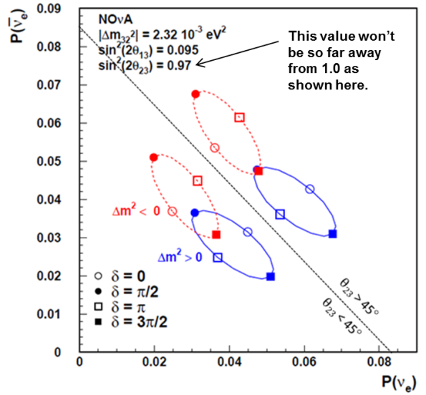
Figure 8: $P\left(ν_{e}\right)$-$P\left({\overline{ν}}_{e}\right)$ probability plot if $θ_{23}≠45°$.

Other Physics Opportunities

The NOνA experiment is able to address physics in areas other than the neutrino oscillation parameters. For instance, the NOνA Far Detector can be used to search for magnetic monopoles. A signature for a monopole would be either a very slow moving particle or a highly ionizing fast moving particles going through the entire detector – without restricting the search to a specific type or origin of magnetic monopoles. Furthermore, NOνA will be used for the detection of supernova neutrinos.

Summary

The NOνA experiment will probe several aspects in neutrino oscillation physics in the coming decade. Recent results for $θ_{13}$ show that it has a large value, which increases the chance that NOνA will be able to determine the neutrino mass hierarchy, and the CP-violating complex phase δ. Precision measurements for $θ_{13}$, $θ_{23}$, $Δm_{32}^{2}$ will be made. The Prototype Near Detector has already been running successfully, and has provided valuable information about the detector construction. The Far Detector construction began in the summer of 2012. The first oscillation events will be observed as soon as the neutrino beam gets turned on in April 2013.

J. Novak, NOvA Technology, Presentation at ANT2010 (2010).
D. S. Ayres et al. (NOvA collaboration), Proposal to Build a 30 Kiloton Off-Axis Detector to Study ν_{μ}→ν_{e} Oscillations in the NuMI Beamline (2005).
D. V. Forero et al., Global status of neutrino oscillation parameters after recent reactor measurements, arXiv:hep-ph/1205.4018v2 (2012).
D. S. Ayres et al. (NOvA collaboration), Technical Design Report, NuMI Off-Axis ν_{e} Appearance Experiment (2007).
P. Adamson et al. (MINOS collaboration), A Study of Muon Neutrino Disappearance Using the Fermilab Main Injector Neutrino Beam, arXiv:hep-ex/0711.0769v1 (2007).

