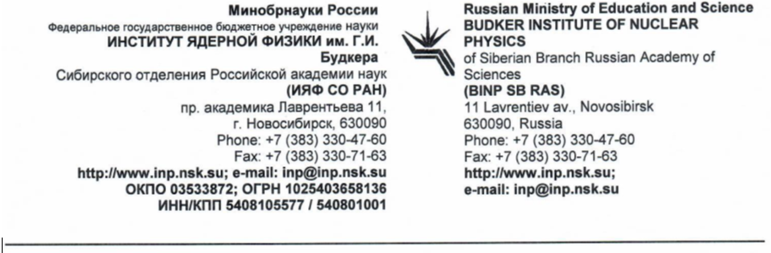

November 2021
To FAIR GmbH
To Dr. David Urner
FAIR In-Kind Office
FAIR Technical Coordinator of CR project

Dear David Urner
Dear Oleksiy Dolinskyy
We kindly ask you to procure for BINP several components required for the Collector Ring according to the Collaboration Contract CC2.5.2.2.1 with maximum of the contractual amount of the PSP or up to the escalated value with FAIR tender.
For PSP 2.9.7.1.1.2.1.1 a contract has yet to be concluded between FAIR and BINP. FAIR will currently not use this PSP until contracted with BINP.
The already contracted PSP 2.9.7.1.1.2.1.2 will be currently used to compensate for PSP 2.9.7.1.1.2.1.1 until contracted. The value to be budgeted shall not exceed the contracted amount.
Lfd. Nr. | PSP-Code | PSP description | Costbook 2005  in k€ | Quantity | Supplier | Contract Name | Number part of table list in Contract | Real value (kEUR) in BINP Contract or escalated | Value FAIR plans to order in 2021/22 (kEUR) (FAIR Vacuum Controller framework agreement)
2a | 2.5.7.1.1.2.1 | Ion Pump Controller (for 2 IPs) | 243,55650 | 19 pcs for ion pump part (4 channels each)  19 pcs for NEG pump part (4 channels each) | BINP | CC 2.5.2.2.1 CR-Rest, 19.06.2018 | # 36 | 314,772421 | 199,82300
2b | 2.9.7.1.1.2.1.1 | pBar Ion Pump Controller (for 2 IPs) | 12,07913 | -/- | BINP | assigned, but not yet contracted | n.a. | 18,7492256 | 0,00
2c | 2.9.7.1.1.2.1.2 | TCR1 Ion Pump Controller (for 2 IPs) | 17,60955 | 4 pcs for ion pumps (4 channels each) | BINP | CC 2.5.2.2.1 CR-Rest, 19.06.2018 | # 49 | 22,7585841 | 22,7585841

Dr. Alexander Krasnov Dr. Dmitry Schwarz
BINP BINP Technical Coordinator

