Vacuum Installation of BINP personnel at the FAIR site

HEBT Vacuum Chamber Contract Batch 1

Total value of contract 0.76M€
No actual price or time frame for the assistance is given in the contract
if the same relative value for the installation of the Batch 1 contract is assumed as for the Batch2&3 contract then the value of the installation would be 39k€.

HEBT Vacum Chamber Contract Batch 2&3 (AFAA2)
Total Value of contract: 1.71M€

HEBT Vacuum Chamber Contract Batch 4 (AFAA4)

Total value of the Contract 4.18M€
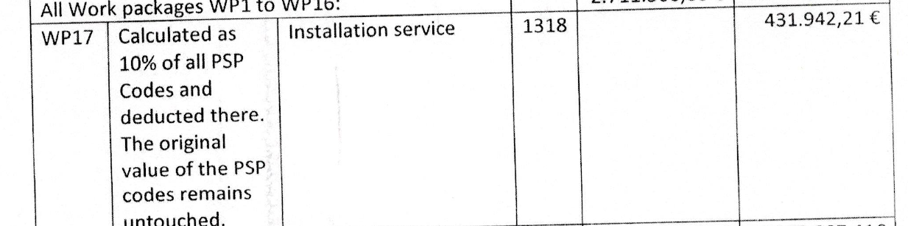

SFRS Beam Diagnostic Vacuum Chambers (AFAA1)

Total Value of contract 1.11M€
Installation is not part of the obligation of the Provider.

SFRS dipole vacuum chambers (AFFA3)
Total Value of contract 0,87M€
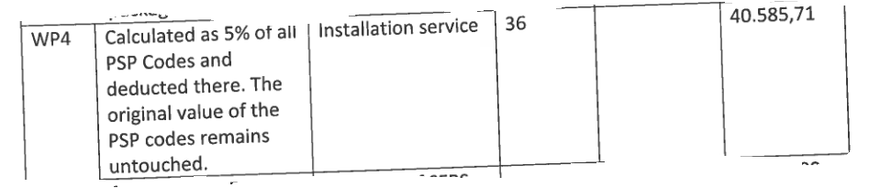

SFRS vacuum chambers rest (AFAA9)
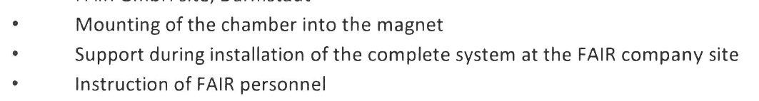
Total Value of contract: 1.84M€
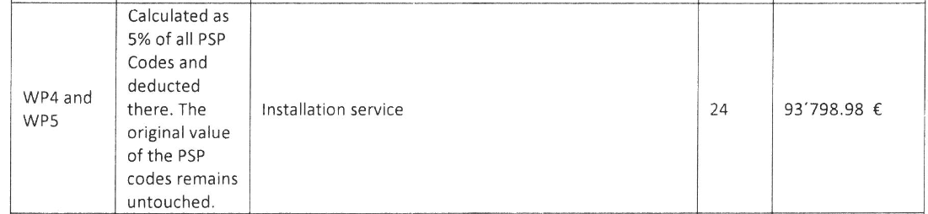
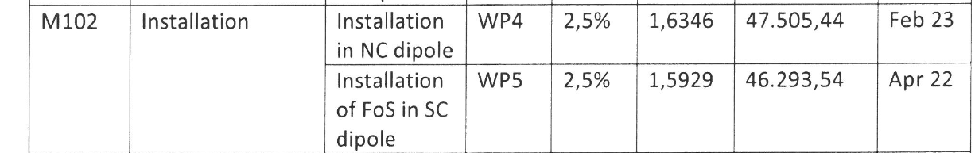

Summary:
A total value of 693k€ installation is being expected from BINP for all current vacuum chamber contracts.
Most of the time the contracts ask for support, or sometimes simple installation. No details of the actual tasks are given.
Further vacuum contracts are foreseen. Also there will be a substantial effort in vacuum installation be needed for the CR, which is fully in the responsibility of BINP.

Issue with actual installations:
The installation work, although always in relation to vacuum chambers and equipment, is varied. Installation can mean installation in a corresponding magnet, on a mount in the tunnel and so on. Installation can only be done, once the vacuum chambers are delivered, but usually needs to be done quite soon after the delivery for logistic purposes at FAIR.
This would result in many small trips of a vacuum team from BINP to FAIR, which is expensive and ineffective (each new team needs to be trained in the local requirements)

Proposal:
If we put all the vacuum installation effort together we will get the possibility of much longer attendance of BINP personnel at FAIR. The idea would be to translate the obligation from money into personnel years, doing installation work at FAIR.
This could be based on the proposed Addendum 3 to the cooperation contract between FAIR and BINP which will be a frame-work-agreement how to account for services related to Contracts between FAIR and BINP.

Decision today:
A pooling of the necessary installation work from all vacuum contracts shall be pursuit with the idea to fulfil the contractual agreement with skilled installation work independent from the actual installation of each individual contract. This does not exclude that for some installation FAIR needs experts for particular installation tasks.
Next Steps:
FAIR will provide a skill set for different possible installation teams
FAIR will provide time frames, when the different skill sets are at current planning required.
These inputs shall be delivered by end of the year 2021.
A framework on how to implement these ideas shall be drafted and exchanged by end of January 2022.

Implementing Addendum No. 3
to the Co-operation Agreement

BETWEEN
BUDKER INSTITUTE OF NUCLEAR PHYSICS (BINP)
of Siberian Branch of Russian Academy of Science
11 Lavrentiev Prospect, 630090 Novosibirsk, Russia
represented by Dr. P.V. Logachev, Director, and Prof. Dr. Yu.A.Tikhonov,
Deputy Director,
“Partner”

AND

FAIR, FACILITY FOR ANTIPROTON
AND ION RESEARCH IN EUROPE GMBH (FAIR)
Planckstraße 1, 64291 Darmstadt, Germany
represented by its Managing Directors Prof. Dr. Paolo Giubellino,
Dr. Ulrich Breuer and Jörg Blaurock,
“FAIR”

The scope of the cooperation considered in this Addendum comprises a frame-work-agreement how to account for services related to Contracts between FAIR and BINP, which go beyond the contracted content.
Method of accounting:
FAIR and BINP agree that these services shall be accounted in work hours for two different categories: technicians, engineers.
one work hour engineers shall be accounted for with 89 €, firm fix price.
one work hour technicians shall be accounted for with 60€, firm fix price.
Process of individual service to be provided:
- if a service shall be required, the two partners agree on type of service (engineer or technician) and the amount of work hours needed to provide the service
- The requesting party sends an official (can be done by email) message to the respective PMO of the other side with
  - a description of the task
  - agreed number of hours and type of support
  - the contract to which the service shall be delivered
- The party to provide the service, shall send a official (email) message back agreeing on task description and type and number of hours of support
Recording of agreed information:
- the information shall be stored in EDMS
- the EDMS information shall be the basis for the accounted services
Payment of services:
No immediate payments shall be done. The payments can be invoiced no earlier than one year after the agreement and not more than one invoice per year. A corresponding amendment to the contract shall be signed, before the final acceptance is issued.

