
Document Title
Detailed Specification for the
PANDA forward Dipole Magnet Power Converter
Power Part and Cabinet

PSP 2.11.11.5.1

Date yyy-mm-dd
2020-03-31
Document Name
DetailedSpecHESR_PANDA_Dipol_PoCo.pdf

Abstract

This document describes the functional details of the PANDA forward dipole magnet power converter in the HESR.
FAIR Division/Group/Supplier
FZJ-IKP4
Prepared by:
M. Retzlaff

Table of contents

Table of contents 2
List of Tables 2
List of Figures 3
1. Introduction 3
2. Abbreviations, terms and definitions 3
3. Scope of the technical system 4
3.1. System overview 4
3.2. Power converter setup 4
3.3. Content of delivery 5
3.4. Spare Parts 6
3.5. Interfaces 6
4. Technical specifications 7
4.1. Technical parameters 7
4.2. Electrical outputs 8
4.3. Electrical inputs 9
4.4. Grounding of the power converter 9
4.5. Interlocks 9
4.6. Interlock classes 10
4.7. Integration of the PC into the MPS 11
4.8. Labelling of power converters 12
4.9. Interface to the 20kV switch gear 12
4.10. DCCT 13
4.11. Electrical supply system 14
4.12. System environment and constrains 14
4.12.1. Location of the power converter 14
4.12.2. Cooling water 15
4.12.3. Losses to air 15
4.12.4. Construction and handling of the power converter 15
5. Quality assurance, procedures for construction and production 16
5.1. Design phase 16
5.2. Production of the system 17
5.3. Tests and acceptance 17
5.3.1. Factory acceptance test (FAT) 17
5.3.2. Site acceptance test (SAT) 18
6. Documentation 18
7. Related Documents 18

List of Tables
Table 1 List of abbreviations 4
Table 2 Type and PSP code of power converters to be delivered by the contractor 5
Table 3 List of spare parts 6
Table 4 Power converter parameters 7
Table 5 Actions to be taken in case of interlock 11
Table 6 Actions to be taken in case of interlock 11

List of Figures
Figure 1 FAIR Overview 4
Figure 2 PANDA forward dipole power converter setup 5
Figure 3 Current and voltage of the load as function of time 8
Figure 4 Pin assignment for the interlock sockets 1SV7 and 2SV7 for PC with 20kV input voltage 10
Figure 5 Signal flow of interlock to MPS 12
Figure 6 Interface to the 20kV switch gear 12
Figure 7 DCCT head 14
Figure 8 Converter placed in the room 15
Figure 9 Location of power converter, TSC and transformer 15

Introduction
The purpose of this document is to specify the detailed requirements for the PANDA forward dipole magnet power supply of the High Energy Storage Ring for Antiprotons HESR at the facility for Antiproton and Ion Research FAIR in Darmstadt.
General technical requirements for all parts and components of the power converter are given in the common specifications [2]. General, legal and technical issues are given in the general specifications [1] and technical guidelines [3], respectively.
However, statements made in this document override the ones in all other documents: the general specifications, the common specifications for power converters, and the technical guidelines.
Contracting body for the equipment described in this document is Forschungzentrum Juelich GmbH. Therefore, all further references to the term Company will refer to Forschungszentrum Juelich GmbH.

Abbreviations, terms and definitions
ACU | Adaptive control unit
Bx | Building x
CID | Component identification number
CDR | Conceptual design report
DC | Direct current
DCCT | DC Current transducer
δI | Permissible deviation of the power converters output current
EMC | Electromagnetic Compatiblity
FAIR | Facility for antiproton and ion research
FAT | Factory acceptance test
FDR | Final design report
FZJ | Forschungszentrum Juelich
GSI | Helmholtz-Zentrum für Schwerionenforschung GmbH
HESR | High energy storage ring
MPS | Machine protection system
PANDA | Antiproton Annihilation at Darmstadt
PC | Power converter
PSP | Project structure plan
PSS | Personal Safety System
SAT | Site Acceptance test
SCR | Silicon controlled Rectifier
SPARC | Stored Particles Atomic Physics Collaboration
TSC | Temperature stabilized cabinet
Table 1 List of abbreviations

Scope of the technical system

System overview
The HESR is the dedicated antiproton and ion accelerator and storage ring for the PANDA and SPARC experiments, with a circumference of 576m.

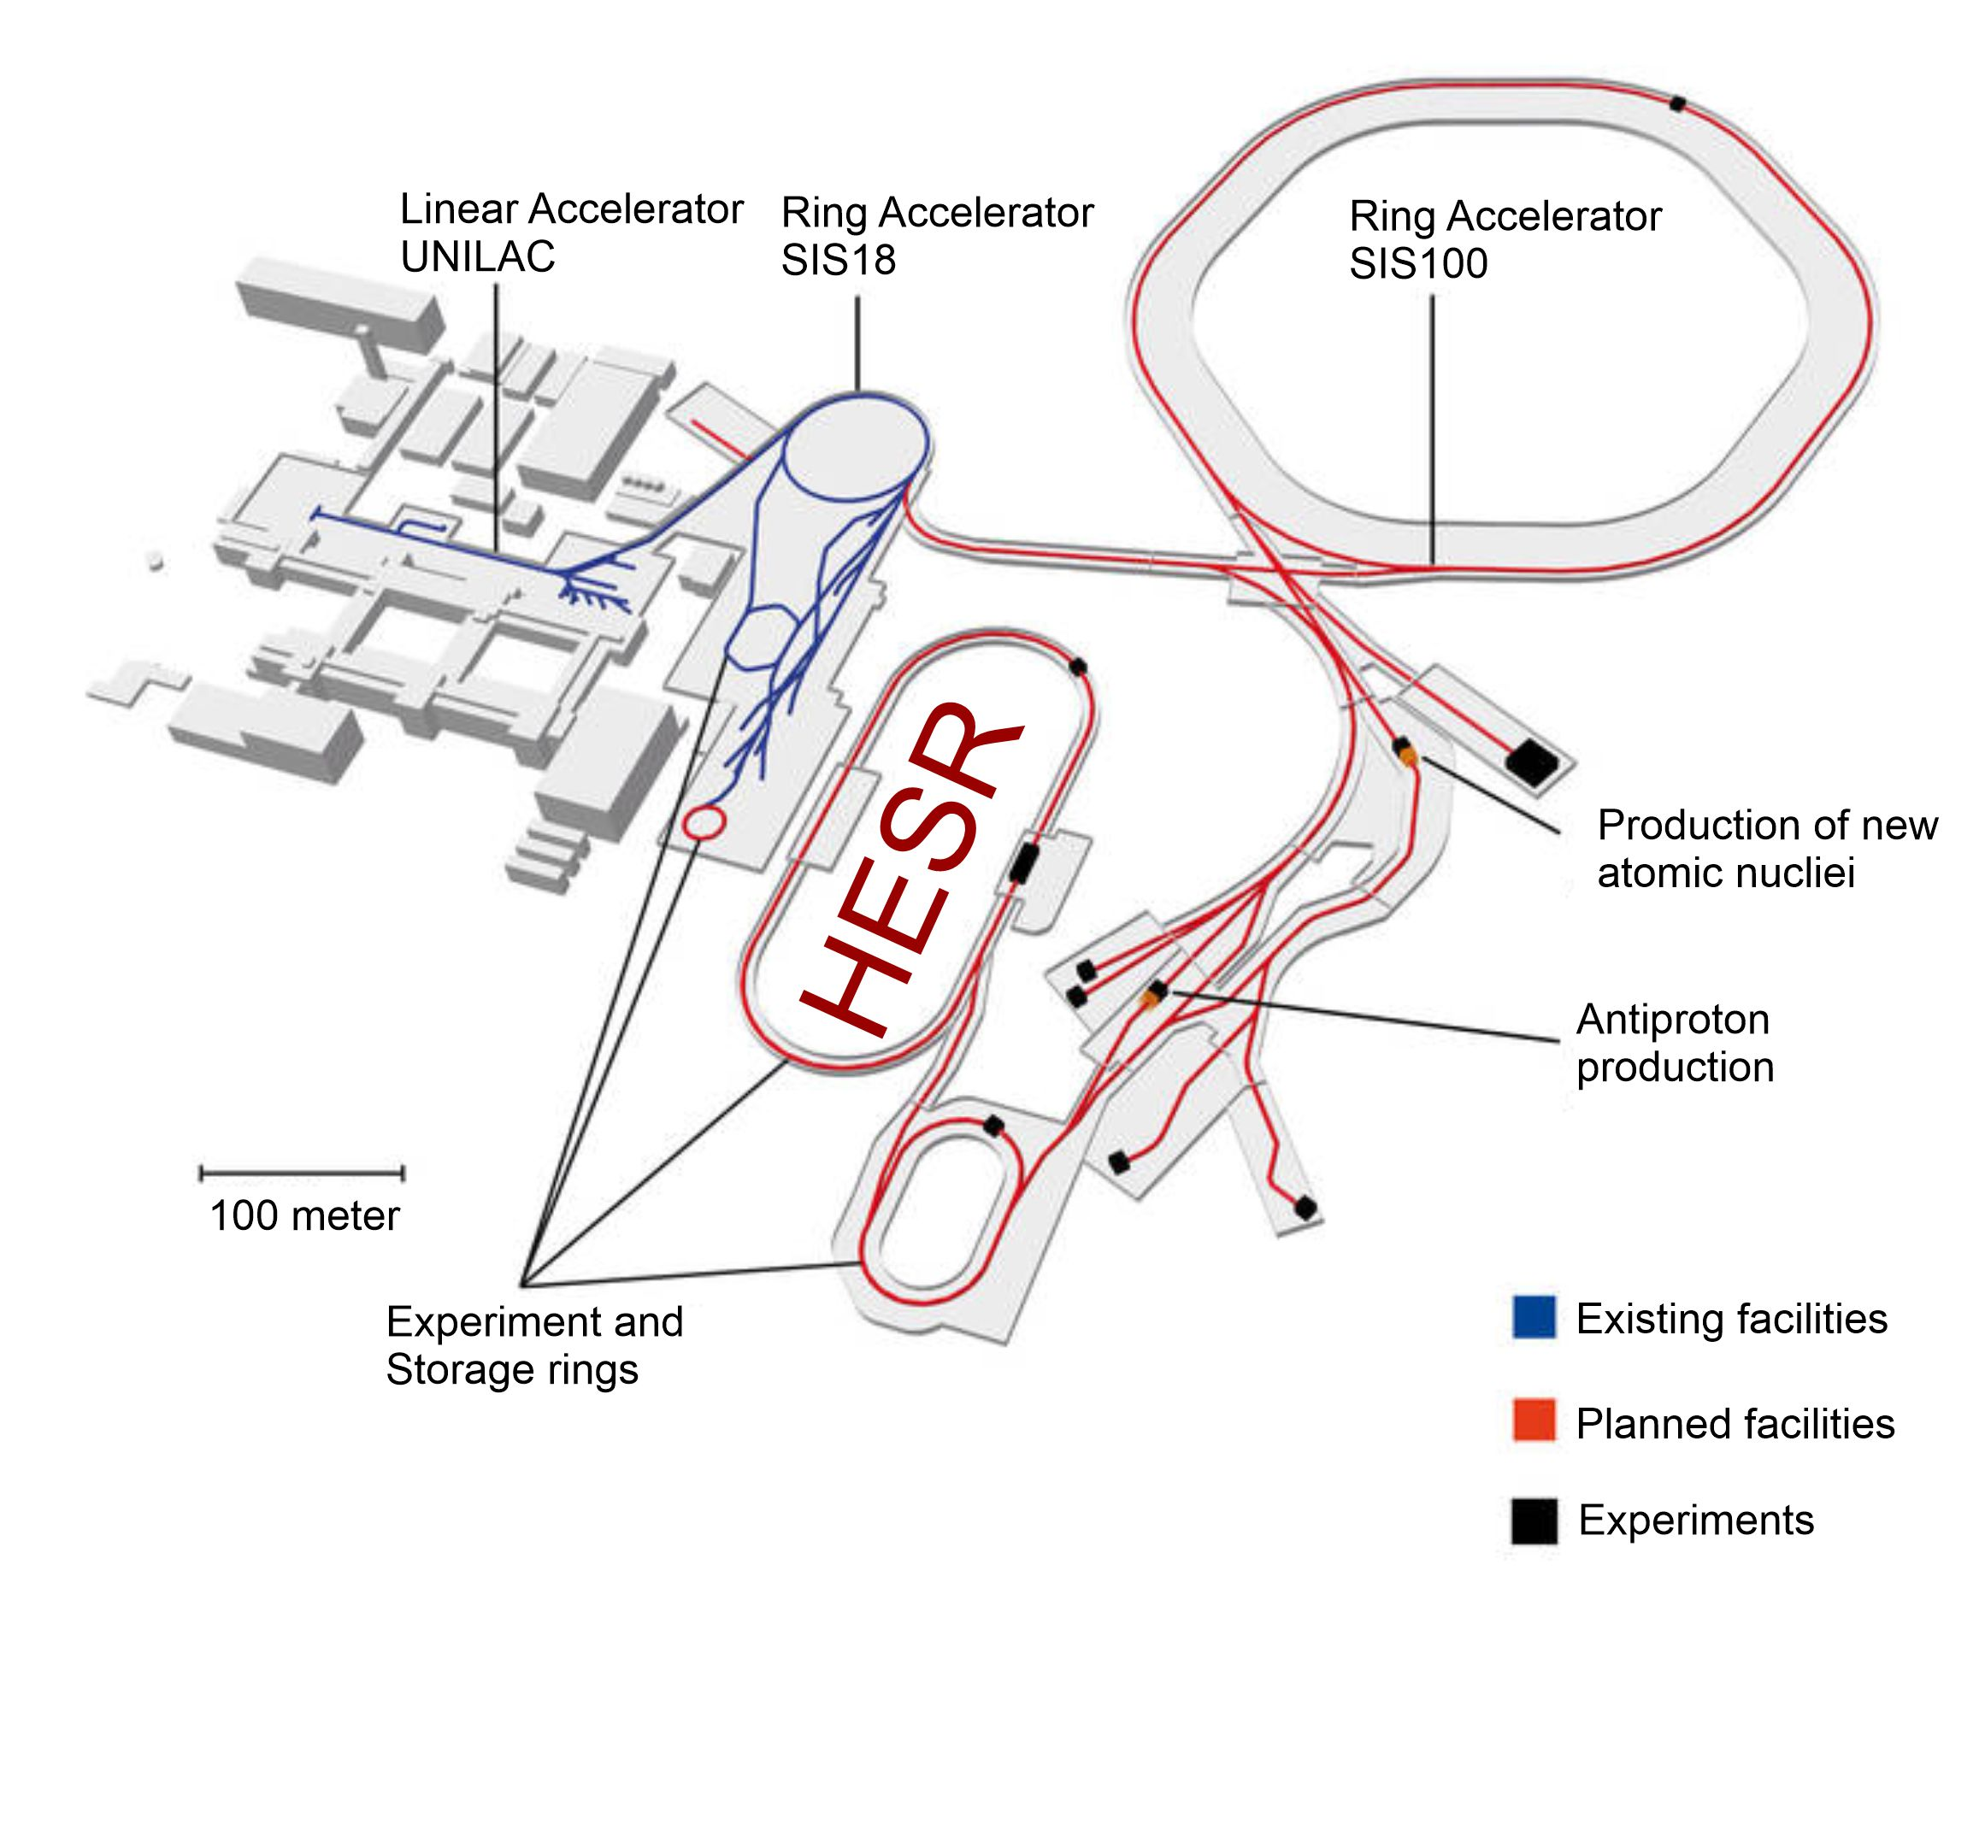
Figure 1 FAIR Overview

The accelerator ring lies slightly lower than ground level and will be covered by earth deposit, while the annex buildings, that support all necessary technical equipment including power converters, are at ground level.

Power converter setup

The PANDA forward dipole magnet power converters can be divided in two parts:
- Power part
It is supplied by a 20kV AC supply system, C2 (Sec. 2.2 of [3]).
- Control part
It is supplied by a 400V AC supply system, which is connected to the 3Phase common supply system C2 (Sec. 2.3 of [3]).

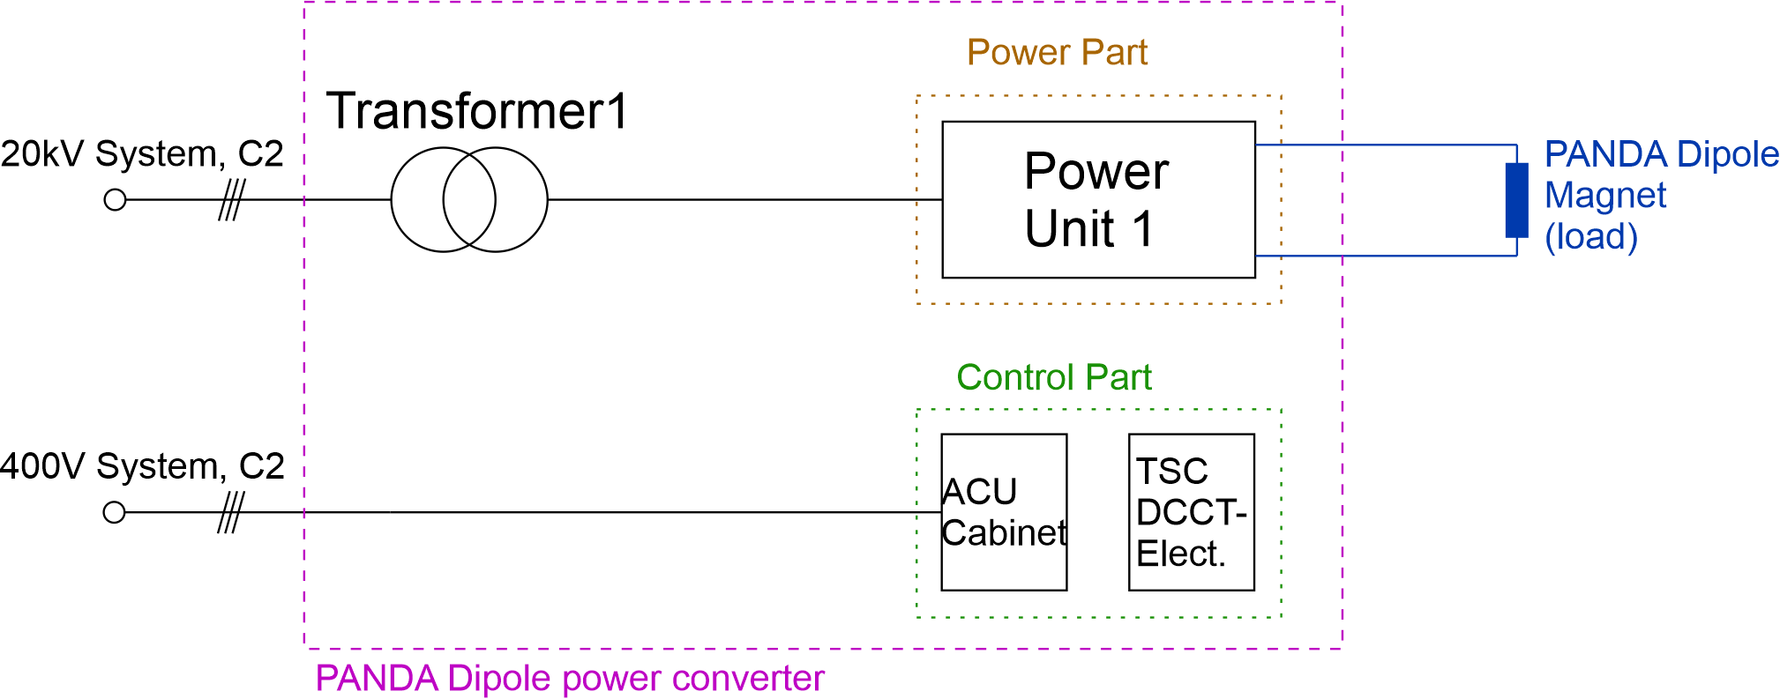
Figure 2 PANDA forward dipole power converter setup

The technical parameters of the power converter are given in table 4. The design principles for the main components and functionalities of the power converter can be found in Sec. 4 of [2] and 8.5 of [2].

The power parts shall supply the loads (PANDA forward dipole magnet) through 6x H07 RN-F 1x300 wires per pole.

The connection of the power converter shall be done according to Sec. 8.5.13 of [2].

From the standardization point of view, it is mandatory for the power converter to be compatible with the ACU systems and DCCTs, which will be provided by GSI.

Further details can be found in Sec. 8.3 of [2], Sec. 8.4 of [2], [4] and in [7].

It has to be noted, that in contrast to Sec. 8.3.1 of [2], GSI will not provide control electronics for 12 pulse SCR topologies. Although, this does not imply, that these technologies are excluded. In that case, the contractor has to implement an own SCR-controller and connect it to the ACU.

Content of delivery
The contractor has to deliver the following power converters:
Item No. | PC Description | PC Type | PSP Code | CID
1 | PANDA forward dipole magnet | HR.D5.01 | 2.11.11.5.1 | 3000011151
Table 2 Type and PSP code of power converter to be delivered by the contractor

Provisions of the contractor:
- Design of the power converter listed in table 2 including CDR and FDR (see Sec. 5)
- Manufacturing of the power converter listed in table 2
- Integration of the ACU system, DCCTs and further provided electronics (if any)
- Factory acceptance tests, FAT, of the main components of the power converter
- Packaging, transportation to and unloading at the FAIR location
- Internal transportation of the power converter to the final location
- Final assembly of the power converter, transformer (if bought by the contractor) and accessories at the final location, including connections to the water system
- Site acceptance test, SAT for the assembled power converter
- Documentation
- Spare parts as described in Sec. 3.4

Provisions by FZJ and FAIR
- Load cables to connect the power converters to the loads will be provided, including connection to the water system
- Input power cables to connect the power converters to the 20kV switchgears and the 20kV switchgears themselves will be provided as well as mounted
- 1 ACU system (Sec. 8.3 of [2])
- 1 DCCT head and corresponding electronics (Sec. 8.4 of [2] and [7])
- One temperature stabilized cabinet (TSC) containing DCCT-electronics and ADC for the power converter

Spare Parts
The following spare parts for the power and control parts are necessary:

Device Name | Quantity in relation to the device number of the same type
Power semiconductors (e.g. diodes, IGBTs, thyristors, etc) | At least 1 set
Power fuses | At least 1 set
Power capacitors (e.g. DC-Link, output filter) | At least 20%
Power resistors (charging/discharging, damping, etc. | 1 set
Contactors and switches (e.g. main contactor, auxiliary contactor, etc.) | 1 set
Water flow control meter | 1 device
Control electronics (e.g. driver cards, voltage-/current sensor cards, line voltage monitoring cards, etc.) | At least 1 device per power part
Control part fuses | 10%
Table 3 List of spare parts

It is to be noted that if the components are assembled in stacks (e.g. IGBT/thyristor stacks), at least one complete stack of each type with the corresponding mechanical, electrical and/or cooling components per system have to be provided. Also, the tools for servicing the stacks must be provided.

The above mentioned amount of spare parts is the minimum requirement. The actual amount of spare parts is to be defined by the contractor, to ensure at least 20 years of operation.

Interfaces
The power converter will have the following interfaces:
- Electrical inputs for the electrical supply systems (see Sec. 3.2 and 4.9)
- Integration of the ACU system and the DCCT (see Sec. 8.3 of [2] and 8.4 of [2], [4] and [7])
- Inputs for interlocks (see Sec. 4.5)
- Connection to the water system (see Sec. 4.10.2)
- Electrical outputs (see Sec. 4.2)
- Interface to the 20kV switch gear (see Sec. 4.9)
- Mechanical dimensions (interface to building, see Sec. 4.12.1)
- Ground connection (see Sec. 4.4)
- Interface to the TSC (see Sec. 4.10)
- Interface to the MPS (see Sec. 4.7)

Technical specifications

Technical parameters

Power Converter for | PANDA forward dipole magnet
Number of converters | 1
Magnets per converter (in series) | 1
Maximum output current [A] | 2000
Nominal output current [A] | 1880
Range of load current [A] | 100…1880
dI/dt for the above mentioned range [A/s] | 24
Resistance of the magnet at room temperature [mOhm] | 95.4
Resistance of the magnet at max. temperature [mOhm] | 100.3
Low field inductance of the magnet [H] | 1.33
Inductance at nominal current [H] | 1.18
Permissible total deviation incl. ripple (peak-peak) absolute: δ₂I (=∆I/I_{N}) | 32ppm (=60mA)
Minimum transition time between flat and slope segments [ms] | 100
Stability over 24h (=∆I/I_{N}) | ±10ppm (=18.8mA)
Absolute accuracy (=∆I/I_{N}) | ±100ppm (=188mA)
Mode of operation | Ramping mode
Cross section of the connection PC->magnet [mm²] | 6x300mm²
Total length of load cables [m] | 60
Total resistance of load cables [mOhm] | 0.6
Table 4 Power converter parameters

Beside the technical parameters mentioned in table 4, the following aspects have to be considered:
- The power converter is operated in ramped mode. Flat top time can vary between seconds and several hours.
- The permissible voltage ripple of the output voltage must be as per the given in Section 8.2 of [2].
- An example of the PC output current profile can be seen in Figure 3

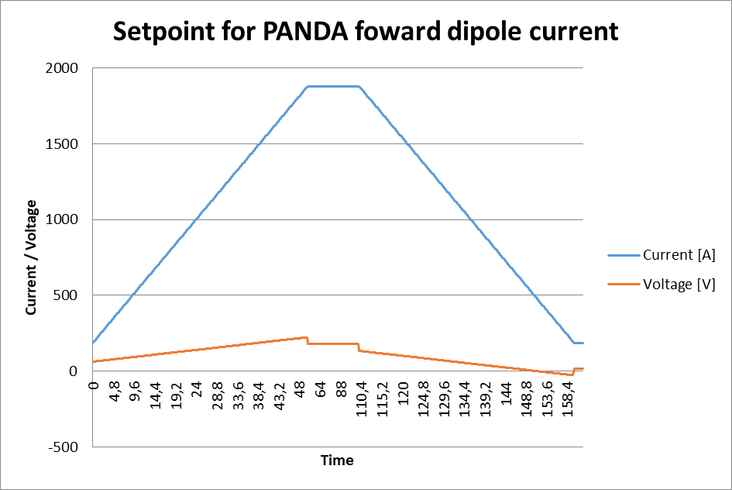
Figure 3 Current and voltage of the load as function of time

- The maximum transition time between flat and slope segments, mentioned in table 4, is specified taking into account that the derivatives of the current set value, up to 2nd order, will have no discontinuities. Additionally, load voltage set values can be available, if necessary.
- A free-wheeling mode of the power converter must be possible for the energy extraction in case of an interlock.
- The total power factor of the converters must be at least 0.9. Any additional components needed to fulfil this requirement are in the responsibility of the manufacturer and has to be placed on the available floor space.
- The power converter has to power warning lights at the magnet, when switched on. For this 24V with at least 1A is needed.

Electrical outputs
The connection between the power converter and the magnet will be done using 6 times H 07 RN-F 1x300 cables per pole. The DC connection brackets have to be made, that cable lugs with 55mm width and 13mm bore hole can be connected.

Strain relief clamps have to be foreseen to fix the wires in the power converter.

All measuring wires, that are connected to high current connections, such as bus bars, have to be short circuit proof (NSGAFÖU-Type or similar).

Electrical inputs
The input terminals for the control part must be equipped with terminals of 2.5mm² and the fuse rating in the low voltage distribution will be 16A (B characteristic, see EN 60898).

As mentioned in Sec 3.2, the power converters will be connected to a 20kV supply system. All cables will be high voltage cables with a cross section of up to 150mm².

The rectification has to be built at least as a 12 pulse technology (see Sec. 3.1.1 of [3]).

Grounding of the power converter
The power converter has to be grounded by being connected to the equipotential rail within building system. This must be done by the manufacturer.
Additionally, each 20kV input power transformer has to be equipped with one metal bolt per phase (primary) and one at ground potential to connect a grounding kit for service and maintenance.

Output terminals of the power converter shall be grounded as described in Sec. 8.5.14 of [2].

Additionally, an active leakage current detection system is needed for the PC. It should be independent from the working point of the main power circuit. This leakage detection system must be protected against short circuit. The active leakage detection system is in the responsibility of the contractor.

Interlocks
The minimum necessary interlocks are listed in Subsec. 8.5.10 in [2].
The beam interlock system (version ‘B’ in Subsec. 8.5.11 of [2]) has to be foreseen.
Interlocks related to the 20kV switch gear, like phase fault, synchronized AC control voltage, 20kV primary current, auxiliary supply fault, etc. have to be foreseen (Sec. 4.9).
The PANDA forward dipole magnet will give one temperature- and one water interlock.
In sum, the following interlock sockets have to be foreseen:
- SV5, 1SV7 and 2SV7 for beam interlock version ‘B’
- SV6 is for interlock signals of the magnet

The SV5 socket for beam interlock system B is a 5 pin female connector of type IEC 610762-101 circular connector Size M12. The SV6 sockets for the interlocks are 12-pin female sockets AEGA-114-FS-13-00-0103-200 for soldering or AEGA-114-FR-11-00-0103-200 for crimping. The 1SV7 and 2SV7 sockets for beam interlock system B are a 6 pin female connector of type Han 3A-HSM angled-L-M20 bottom closed, cable gland Han CGM-P M20x1,5 D.10-14mm and inserts Han 7D-F Quick Lock 1,5mm². All cabling for this socket have to be done with a cross section of at least 1,5mm²
The pin assignment for SV5 is presented in Sec. 8.5.11 of [2], for SV6 in Figure 25 of [4] and for 1SV7, 2SV7 in Figure 5.

For additional information on the actions to be taken in case of an interlock, see Sec. 4.6.

Any necessary additional interlock must be proposed by the contractor.
At least, one spare interlock has to be included.

In contrast to Sec. 8.5.11 in [2] the beam interlock system ‘B’ requires the following setup:
- An Interlock socket SV5 with the pin assignment for beam interlock system ‘A’ described in Sec. 8.5.11 of [2].
- Two Interlock sockets (1SV7 and 2SV7) with the pin assignment shown in Figure 5
- A redundant configuration for the control of the 20kV circuit breaker (Figure 6).
- Positively driven contacts have to be used for the auxiliary contacts of the main contactors and of the soft start contactor (if any) (1K10, 2K10, see Figure 4 and Figure 6), a MTTF of >217 years for these contactors is mandatory (calculation needed for the FDR).
- The maximum load to be handled by the contacts of the PSS is 5 A. Therefore, the continuous power consumption for 1K10 and 2K10 is not allowed to exceed this value. It is mandatory that these contactors have to be fused with 6A (C characteristics or gL/gC characteristics) at maximum.

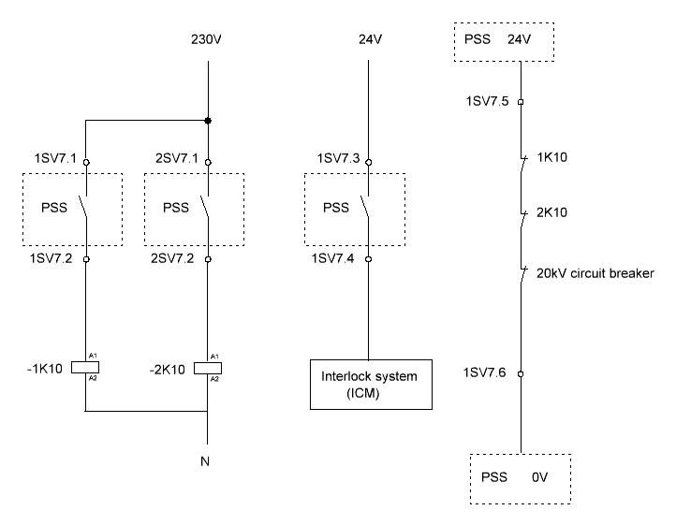
Figure 4 Pin assignment for the interlock sockets 1SV7 and 2SV7 for PC with 20kV input voltage

Interlock classes
In general, all interlocks can be divided in two classes. The classes of interlocks correspond to the action that should be taken in case of an interlock
Class 1: PC – Turn off; 20kV input circuit breaker – unchanged
Class 2: PC – Turn off; 20kV input circuit breaker – open

Interlock class | Power part | Input circuit breaker
Class 1 | Turn off | No change
Calss 2 | Turn off | Open
Table 5 Actions to be taken in case of interlock

Interlocks of class 1 are (i.e.):
- Signals which monitor temperatures
- Water faults
- Earth fault
- Fan fault

Interlocks of class 2 are (i.e.):
- Internal fast off button of the power converter (realized by EN13849-1 certified relays – performance level e)
- External fast shutdown system (realized by EN13849-1 certified relays – performance level e)
- AC Phase fault (20kV / 400V)
- Fuse fault
- Short circuit of primary current

Integration of the PC into the MPS
The PC has to interact with the MPS as described in Table 6. These actions must be taken together with the ones mentioned in Sec. 4.6 of this document.

Type of Interlock | Power Converter (PC) | MPS
Internal | Turn off | Send information
External | Turn off | Send information
δI violation | - | Send information
Table 6 Actions to be taken in case of interlock

The actions described in Table 6 will be managed by the ACU system.
An interface card to connect the PC and the MPS will be provided by FAIR/FZJ. In case of an interlock, this card will send the information from the Interlock Control Module of the PC to the MPS (see Figure 5).
The signal sent from the interface card to the MPS can be either optical or electrical. In any case it must be taken into account that an electrical signal cable (MSB.00.250.LTE – Lemo), which shall be provided and installed by the contractor, will be connected to the front panel of the ACU Frame (SCU card). This connection will be done by the company. The integration of the interface card shall be done by the contractor.
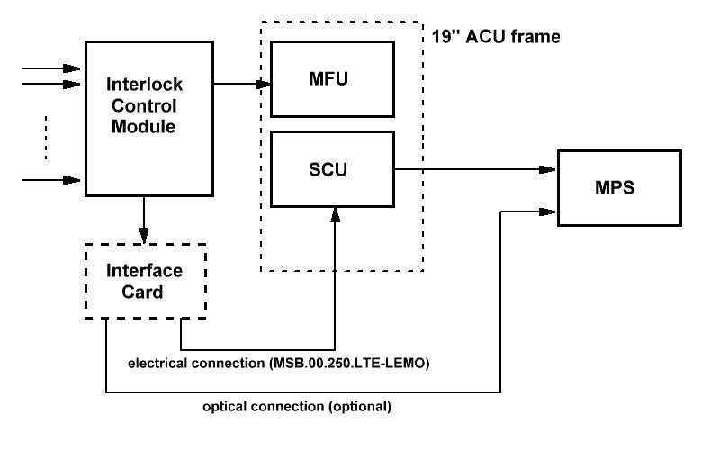
Figure 5 Signal flow of interlock to MPS

Labelling of power converters
The labelling of the power converters has to be done according to Sec. 8.5.8 of [2]. The reference to the document is listed in table 2.

Interface to the 20kV switch gear
The PANDA forward dipole power converter will be fed by one AC circuit breaker. The breakers are located in a 20kV switch gear system located in Room 204, level 15. General information about the interface to one 20kV switch gear is shown in Figure 6.
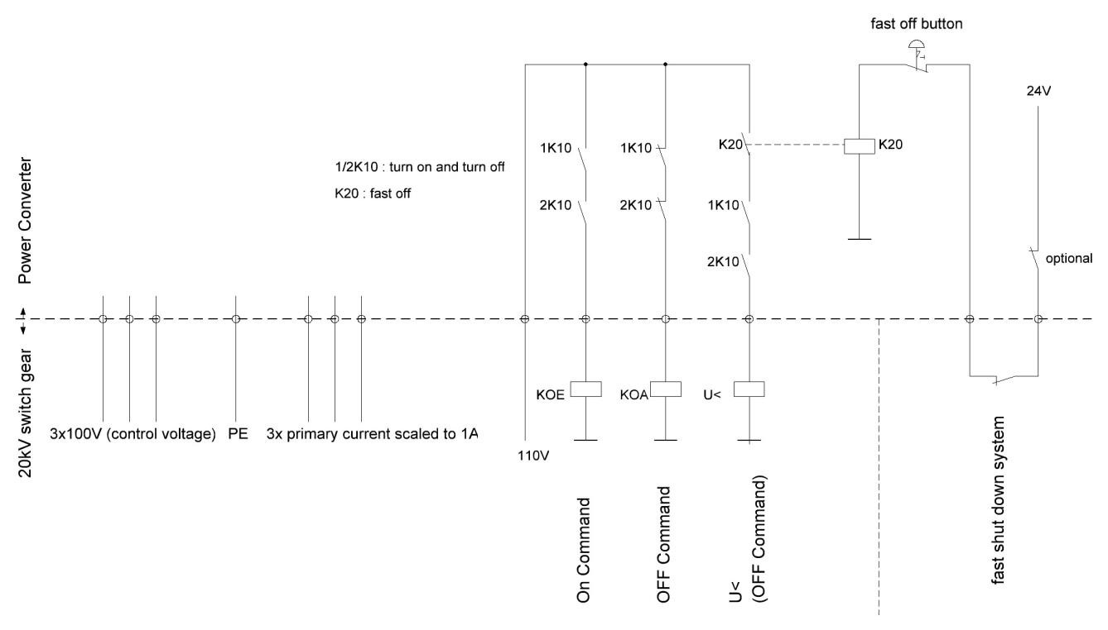
Figure 6 Interface to the 20kV switch gear

The contactors 1K10 and 2K10 in figure 6 handle the turning on and turning off of one 20kV AC circuit breaker. K20 has to be linked to the internal fast off button of the power converter and interact with all AC circuit breakers of this PC.
Further interlocks of each power converter which are safety relevant have to trip the corresponding contactor K20 as well.
Not shown in Figure 6 but to be considered are the following signals:
- status of circuit breaker (on, off)
- status of ground switch (on, off)
- fuse fault 110V
- I>
- I>>

DCCT
The general summary of relevant information and installation requirements of the DCCT and ADC are given in [7]:
- easy access to DCCT and ADC components
- easy installation and deinstallation of DCCT and ADC components
- primary bus-bar through the centre of the DCCT head bore with appropriate fixation
- DCCT electronics, ADC and ACU are independent 19” frames,
- DCCT related electronics and ADC card shall be installed in a separate temperature stabilized cabinet (TSC). The TSC will be provided by the company (maximum size WxDxH: 80x91x180cm + 50cm height for heat exchanger). The TSC shall be installed in a way that easy access to the front and back doors is possible
- the water with 18°C shall be supplied by means of 1/2’ pipe with appropriate water valve
- The DCCT head has to be installed inside the PC in such way that the sockets on the DCCT head are easily accessible (for calibration purposes).
- appropriate clearance distances due to DC stray magnetic field
- appropriate clearance distances due to AC stray magnetic field

The TSC will be built up and delivered by the Company. The DCCT head still has to be integrated and installed at the output of the PC by the contractor. For the integration of each ACU system and DCCT/ADC, it must be noted, that connections between TSC and the ACU system are needed. The ADCs (located inside the TSC) will be connected via Ethernet cables (provided by the company) to one of the free connection ports located on the back side of the ACU system (19” crate). The connection between the TSC and the ACU systems will be done by the company. However, the contractor has to foresee these connections. Additionally, the DCCT head has to be connected to the TSC using a cable provided together with the DCCT head. This must be done by the contractor. Both cables (DCCT head → TSC and TSC → ACU system) have a maximum length of 20m. Preferably less than 15m. The necessary lengths have to be noted in the CDR.
For the FAT purpose the company provides the configuring of the DCCT/ADC as class 2.2 [7] without TSC. For the SAT the company provides appropriate TSC. The integration of the TSC must be done by the contractor with the support of the company at the place of installation. All agreements in this regards shall be reached during CDR and FDR.

The expected size of the DCCT head is mentioned in figure 7.
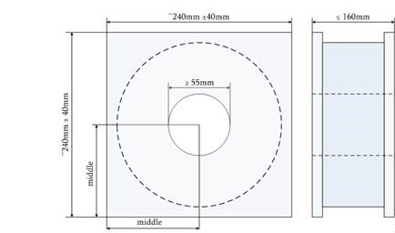
Figure 7 DCCT head

If the DCCT head is mounted close to inductive components, magnetic shielding has to be installed, to protect the system against stray fields.

The return bus bar has to be mounted either in at least 30cm distance from the outer hull of the head. Or preferably symmetrical, with a minimum of two bus bars beside the head.

Electrical supply system
The power parts of the power converters are going to be fed by the 20kV supply system C2.
All electrical interfaces for control parts are going to be fed by a 20kV/400V transformer connected to the common supply system feeder C2 (Sec. 2.2 of [3]).
The total harmonic contents of the power converters have to fulfil the allowed harmonic content which is described in details in Sec. 3 of [3].
The total harmonic contents have to be simulated by the contractor and the results have to be communicated to the company (see Sec. 3 “case C” of [3]).

System environment and constrains
Some general environmental conditions and constrains that shall be considered, like water cooling system and mechanical properties of the installation location as well as interactions of the power converters with the installation location environment, are described in Sec. 6.1 of [2] and Sec. 7 of [2].

Location of the power converter
The converter must not exceed 2.2m x 2.8mx 1m (height x width x depth). Figure 8 shows the converter located on the left side of the room. On the right side, there is a compressor, that has to share the room with the converter.
Figure 9 shows the location of power converter, TSC and the 20kV transformer.

Figure 8 Converter placed in the room

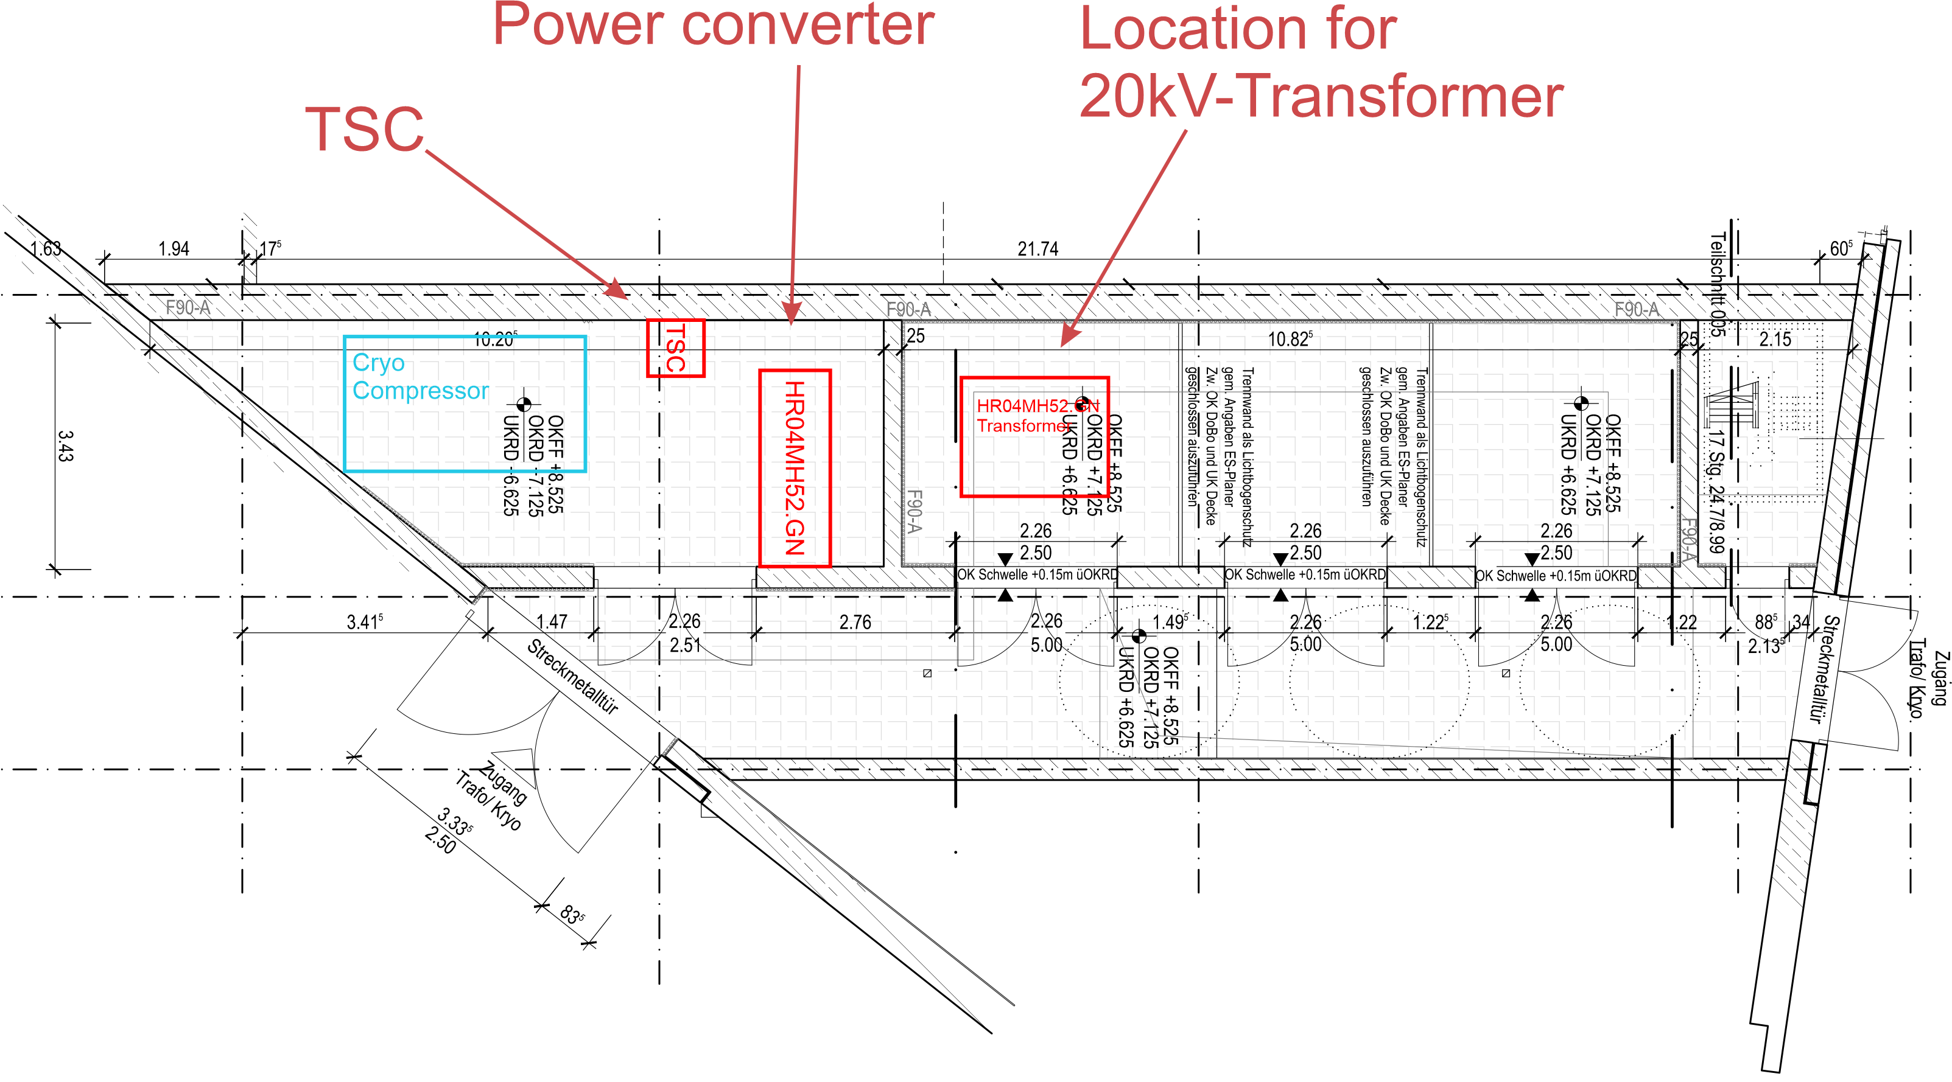
Figure 9 Location of power converter, TSC and transformer

Cooling water
For the power converter, there is a maximum amount of cooling water of 60l/min available. Further details are given in Sec. 6.1 of [2], Sec. 7.2.2 of [2] and Sec. 8.5.9 of [2].

Losses to air
The losses to air are limited to 10kW per power converter. Further details are given in Sec. 8.5.9 of [2].

The transformer rooms are designed with a ventilation system, that is capable of dissipating 30kW through air for each power converter.

Construction and handling of the power converter
General rules on construction of the power converter are given in Sec.8 of [2]. Also the standards of [11] have to be followed.

Quality assurance, procedures for construction and production
General design aspects, quality assurance, tests and acceptance procedures are specified in the general specifications [1], the technical guidelines [3] and within the contract. Main and specific points for the systems specified in this document are listed below and they substitute what is mentioned in Sec. 9 of [2] and Sec. 9.1 of [2].
All systems must be built taking into account the Sec. 1.6 of [3].
The realisation process of the specified systems consists of the following phases:
- Design and preparation of the production:
  - Design
  - Conceptual design review (CDR)
  - Creation of manufacturing documents
  - Final design review (FDR)
- Production of the system, FAT and shipping
- Installation, commissioning and testing at the FAIR site (SAT)

Monthly status reports are mandatory during all phases. The deliverables of each phase and the corresponding rights will become property of FZJ.
Additionally, it must be noticed that a set of documents, listed in Sec. 11.1 of [2], have to be delivered during the tendering process.

Design phase
Conceptual design review (CDR) and final design review (FDR) FZJ and the contractor shall be done to complete the “Design development and preparation of the production” phase, mentioned in Sec.5.
During CDR, design documents will be discussed. More in detail, the following information the power converter has to be provided:
- Functional description of all components
- Explanation of design criteria according to Sec. 8.5 of [2]
- Technical data
- Block diagrams
- Manufacturer and types of all main components
- Description of interfaces (control interfaces and interfaces to the environment)
- Simulations:
  - Operation modes given in this detailed specifications (Sec. 4)
  - Influence of the power converters operation on the supply grid (grid voltage fluctuation, current and voltage harmonics (up to 49th), active, reactive and apparent power)
- Draft version of the production plan
- Test concept to ensure testability during FAT and SAT
- Definition of the critical components which are operated on the verge of or beyond to their specification limits
- Draft version of the risk assessment
During FDR, additional to the design documents, manufacturing documents will be discussed. More in detail, the following information have to be provided:
- A description of the complete power converter
- Detailed specifications of all main components (technical and mechanical data) i.e. cabinets, transformers, inductors, capacitor banks, arrangement of semiconductors, placement of DCCT-head
- 2D or 3D illustrations of the physical configuration of the complete power converter (components placement inside the cabinets)
- Block diagrams and schematics of the control loops
- Complete schematics of all the electrical circuits
- Complete specifications of all the interfaces (electrical, mechanical, building, media, software, etc.)
- List of recommended spare parts
- Provision of design and production documents (production plan, quality plan, work instructions and test instructions)
- Test plans and templates of test protocols for FAT and SAT
- Adjustment plan, if necessary
- Draft version of the transportation specification (dimensions and weight with and without packaging)
- Risk assessment
- Draft version of the operating manual

Draft versions of documents must be available at least 14 days before each review respectively.
A formal acceptance given in written form by the company after each review is mandatory. This means, that the production of the documents for FDR shall start only after CDR is complete and respective design documents are accepted by the company.
In general, design and manufacturing documents together contain all needed information to start the production without further R&D activities.
Any material acquisition by the contractor prior to the formal production release is on the risk of the contractor. However, it can be agreed separately with the company.

Production of the system
The production phase starts after successful completion of the FDR process.
During this phase, the contractor shall fabricate or procure the main components and/or preassemble modules for FAT and shipping, according to the production plans approved during FDR (see Sec. 5.1).
No pre-series prototype shall be produced and approved.

Tests and acceptance
For general information on the tests and acceptance refer to Sec. 9.2 and Sec. 9.3 of [2]. Additionally, consider the following topics:

Factory acceptance test (FAT)
FAT of the pre-assembled modules has to be performed according to 9.2.2 of [2], if applicable. If not, a detailed test procedure plan has to be prepared and agreed during FDR.
Main 20kV input transformers shall be tested according to Sec 7 of IEC 61378-1.
Main inductors have to be tested according to IEC 60076-6.
Functional tests in short circuit operation (output) shall be done. For this, test transformers with 400V input and reduced power rating may be used. However, individual factory acceptance tests at full power rating are required at the subcontractor’s sites for main components above mentioned like power transformers, smoothing inductors etc.
It must be noted that any additional tests which are necessary from the contractors’ point of view, must be proposed during the design phase.
EMC tests described in Sec. 7.1.2 of [2] have to be done only for the 400V input and the DC output terminals. They don’t need to be performed on the primary or secondary terminals of the 20kV transformers.

Site acceptance test (SAT)
After successful FAT the shipment of the components and allowance for installation at the company’s site, starts. The power converters have to be fully assembled and installed. Details on the installation time window will be given in the contract. After installation, the SAT must be carried out.
SAT comprises of 3 parts (SAT Aa, SAT Ab and SAT Ba, see Sec. 9.3 of [2]). They will be performed by the contractor at the final location of the power converters. In addition, oppositely to what is mentioned in Sec. 9.3.1 of [2], during SAT Ab, the passivating of the cooling system doesn’t have to be done. SAT Ab only involves the scouring of the cooling system with de-ionized water.

Documentation
Concerning the details about the documentation, refer to Sec. 11 of [2]. According to 2006/42/EG, the assembly, operation and service manual has to be supplied by the contractor at least in German or preferably in English and German (in contrast to Sec. 11.2 of [2]).

Related Documents
- F-GS-F-01e-General_Specification_v1_2
- Common Specifications on Power Converters, F-CS-PC-01e_v1_4
- F-TG-ET-01e_Electrical_Design_Rules_and_Regulations_v3.0
- F-TN-PC-01e_ACU-Integration_v1.0
- F-TN-PC-04e_ACU_System_Description_v1.0
- F-TN-PC-03e_DCCTforFAIR_v1.0
- F-TN-EPS-en-0006_DCCT_class1_and_2_Installation_in_Power_Converter_V002
- F-TG-F-03e_Supply_with_cooled_water_v1.1
- F-TG-T-01e_Transport_v1.3.
- F-TG-T-03e_Installation_v1.1
- C-TG-GAT-de-Schaltschrank-und_Verdrahtungsqualitaet-V001

